Bitterroot River Protection Association a WATERKEEPER Affiliate
215 Main Street, Stevensville MT 59870
Office phone: 406.777.2995 Director’s cell: 406.239.4838
bitterrootriverprotection@gmail.com www.bitterrootriver.org
ANNUAL REPORT
Dear members and prospective members,
We have had a very eventful year. In 2014:
- Working with the Ravalli County Commissioners, we were able to establish nine new Portage Routes on the Bitterroot River under the Stream Access Law.
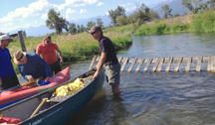
- Working with Montana Department of Fish Wildlife and Parks, an innovative float through gate was designed and installed at one of the sites and could become a good model for future use around the state.
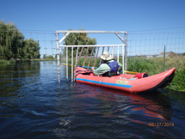
- BRPA filed a 310 Permit Complaint and got a precedent setting decision by the Bitterroot Conservation District recognizing that it has jurisdiction over “revetments” once the river has reached them. Some landowners were skirting the permit process by burying piles of concrete rubble/stones or simply piling them along the river far enough from the bank so as not to trigger a permit process. Now they can be forced to remove the rubble when the river does reach it.
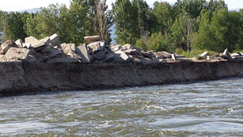
- Working with FWP and the Ravalli County Road Department, we helped facilitate the restoration of a boat landing and launch site at the Conner bridge. The boat launch was inadvertently abolished when emergency work was done at the site to save the bridge from being washed out.
- We are working with the USFWS and FWP at the Lee Metcalf National Wildlife Refuge to try and clean up the asphalt that has fallen into the river as the river has moved to the east in the area
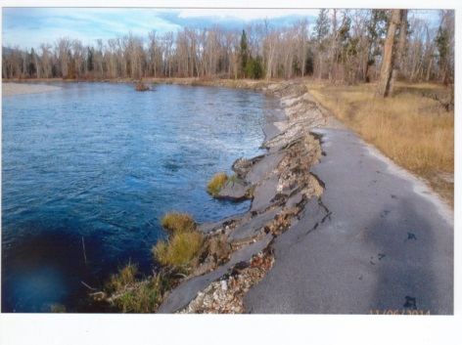
.
- We also participated in moving the educational shelter that was threatened with being washed away by the change in the river’s course. Just in time, too! Within a few weeks of dismantling and removing the shelter a large ponderosa pine on the bank fell across the concrete foundation
. 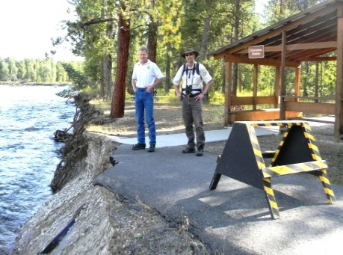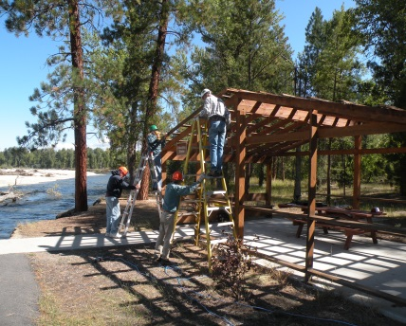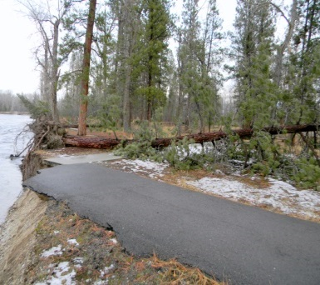

- We lobbied hard, but unsuccessfully, to prevent the County Commissioners from lifting the prohibition on any new residential construction in the Flood Plain. However, a few good rules were added to the existing regulations thanks to the diligence and tenacity of FWP fisheries biologist Chris Clancy. BRPA is now receiving direct notification of all Flood Plain Permit applications in the Bitterroot River drainage and will be monitoring the process.
- We are participating in the statewide Total Maximum Daily Load (TMDL) process in which the state is identifying streams that are ecologically “impaired” and implementing voluntary efforts at restoring those impaired streams. As part of this process, BRPA is initiating an effort to do a drainage wide water sampling program in the Burnt Fork of the Bitterroot where the North Burnt Fork Creek has already been identified as being impaired due to nutrients.
About the lawsuits: There are currently five Wastewater Discharge permits for discharges directly into the Bitterroot River. Three are for municipalities, including Hamilton, Stevensville, and Darby. The other two are for Rocky Mountain Laboratory and Glaxo-SmithKline laboratory both of which are processed through the City of Hamilton’s sewage treatment plant.
According to DEQ there are four active permits in the valley for significant discharges to groundwater, they are: the Corvallis Sewer District; Kootenai Creek Village, Victor; One Horse Acres, Florence; and Wildflower Subdivision, Hamilton.
The Wildflower Subdivision is located in the vicinity of the two permits that BRPA is contesting in court: the Grantsdale Addition and the Lee Foss/Retail Store development. We are asking for an analysis of the potential impacts of these groundwater discharge permits on the surface water of the Bitterroot River and for a cumulative impacts analysis.
If we are successful in our complaints DEQ will be required to do a non-degradation analysis of the potential negative impacts to the surface water of the nearby Bitterroot River by these or any other proposed wastewater treatment systems being installed along the river. If successful these lawsuits will precipitate a reform in the DEQ permit approval process across the state.
We are working hard for you and for the Bitterroot River and very much appreciate your support! If you haven’t renewed your membership for 2015, now is the time. If you are not yet a member and want to join or simply want to contribute now is the time for that as well!
Sincerely,
Michael Howell, Program Director
Help us help the Bitterroot River!
Become a member: 1 year $ 25 2 year $ 45 3 year $ 65 Lifetime $100
and/or Make a tax deductible donation of any amount!
Send checks to: BRPA, P. O. Box 8, Stevensville MT 59870

