WHAT DOES THE BITTERROOT RIVER PROTECTION ASSOCIATION DO?

RIVER EDUCATION RIVER ACCESS
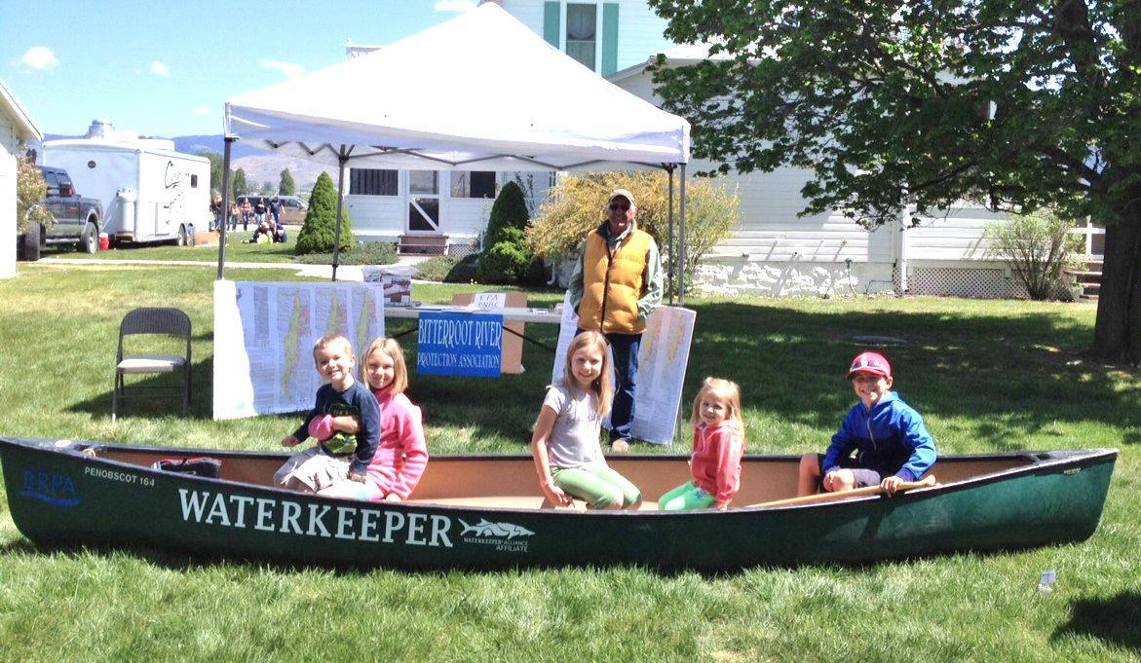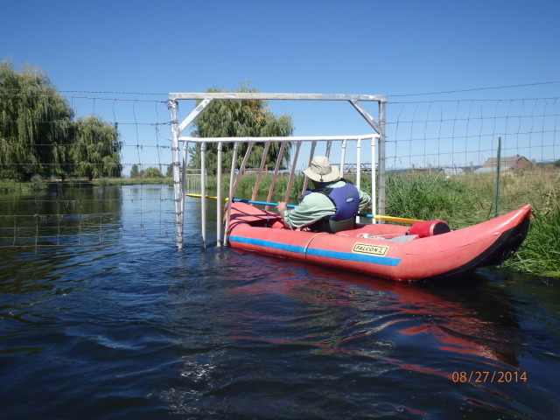
Involving the next generation A float-through gate keeps the livestock in
and lets the boaters float right through
RIVER CLEAN UP
When an asphalt sidewalk at the Metcalf National Wildlife Refuge fell into the river, BRPA was there to clean it up
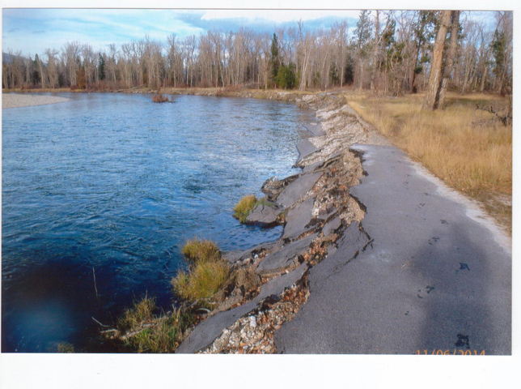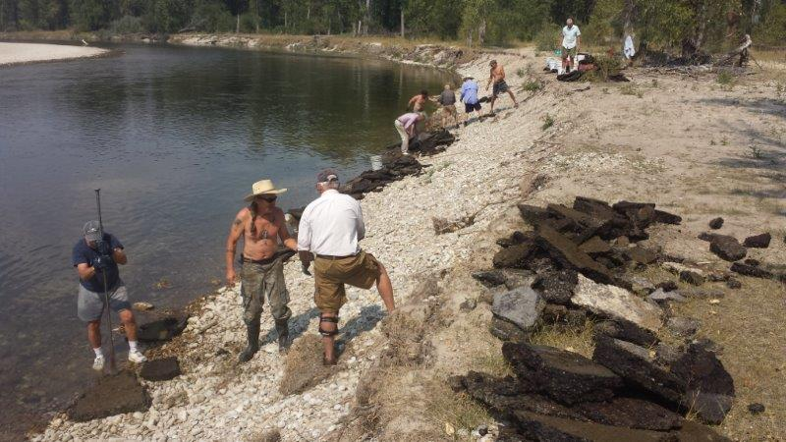
RIVER WATCH
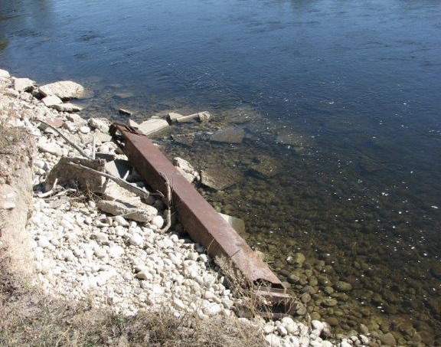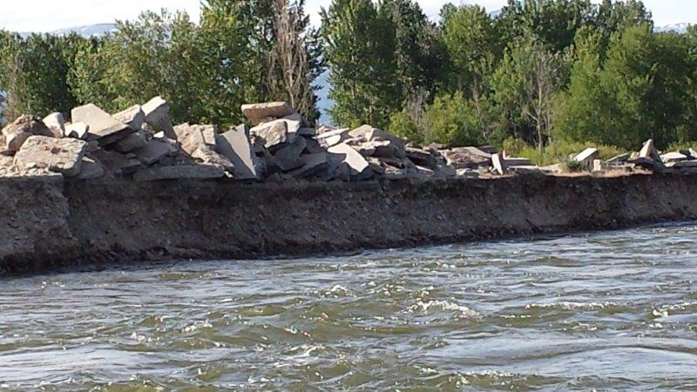
BRPA keeps an eye out for hazards and unauthorized activities on the river
RIVER HEALTH
The Bitterroot River Health Check, a program initiated and steered by BRPA, is a community-based water quality monitoring program supported by a collective of individual community members, local businesses, and non-profit organizations, as well as the UM Bitterroot College.
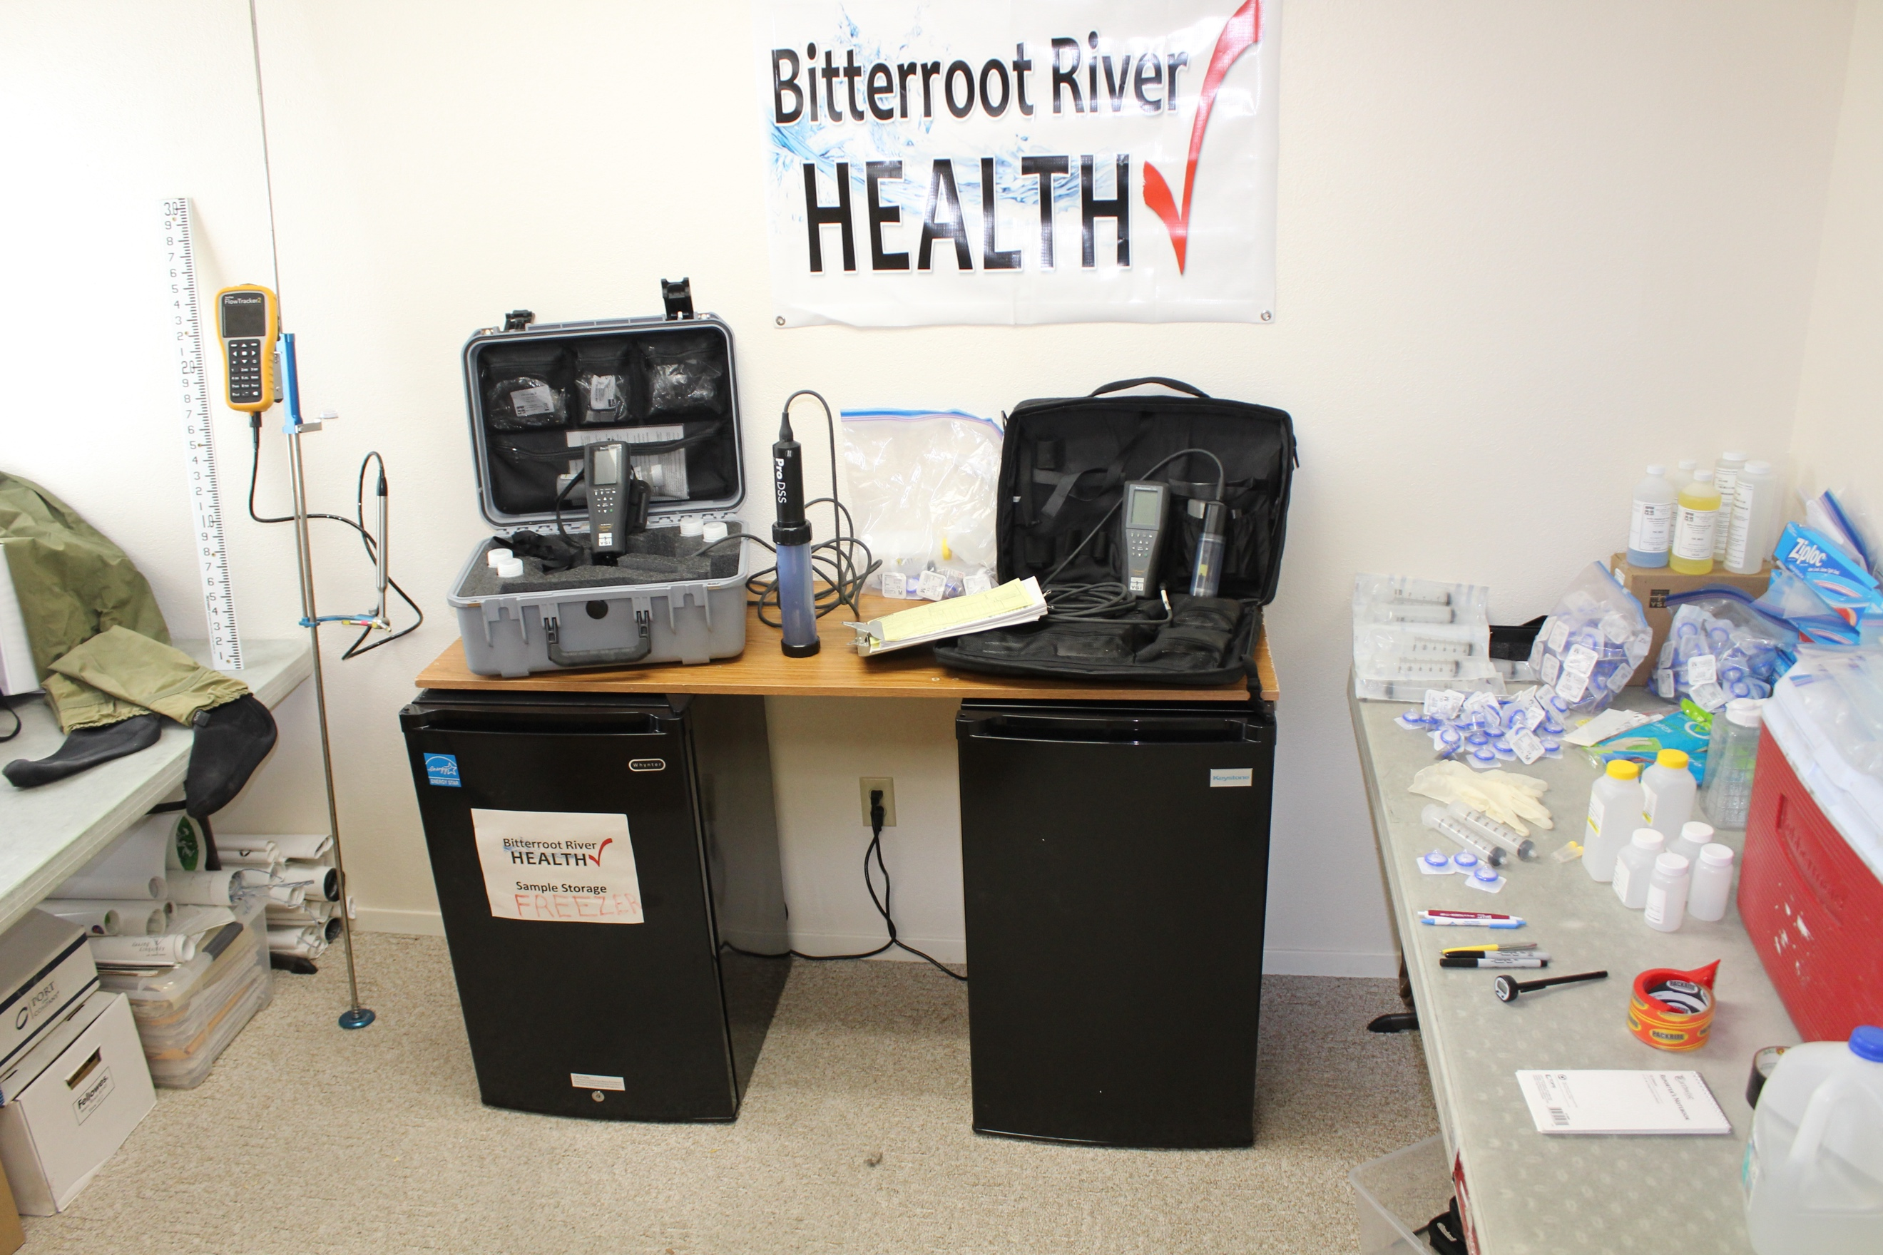
It is a “Citizen Science” based program that sponsors a team of vounteer monitors trained in the protocols for taking water quality samples in the river, streams and lakes of the Bitterroot River Basin. The all-volunteer teams work without charge to aid both state and federal agencies in agency sponsored water quality monitoring projects, in training and educational programs at the UM Bitterroot College and in university related research projects, as well as other independent water quality monitoring projects in the Bitterroot River watershed.

WORKING WITH FEDERAL AND STATE AGENCIES AND THE TRIBES
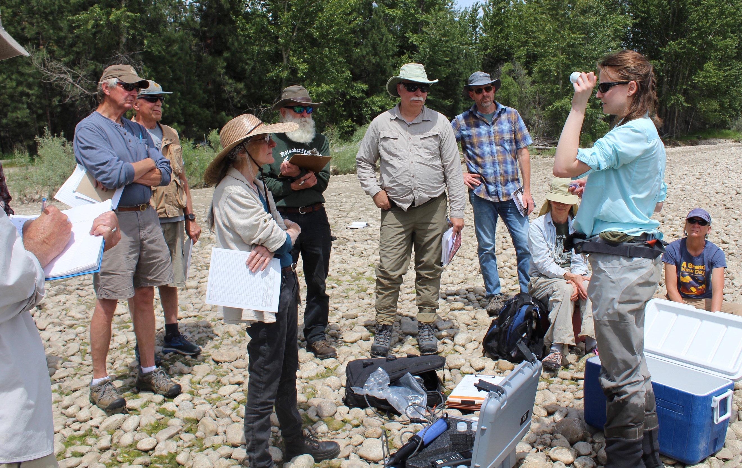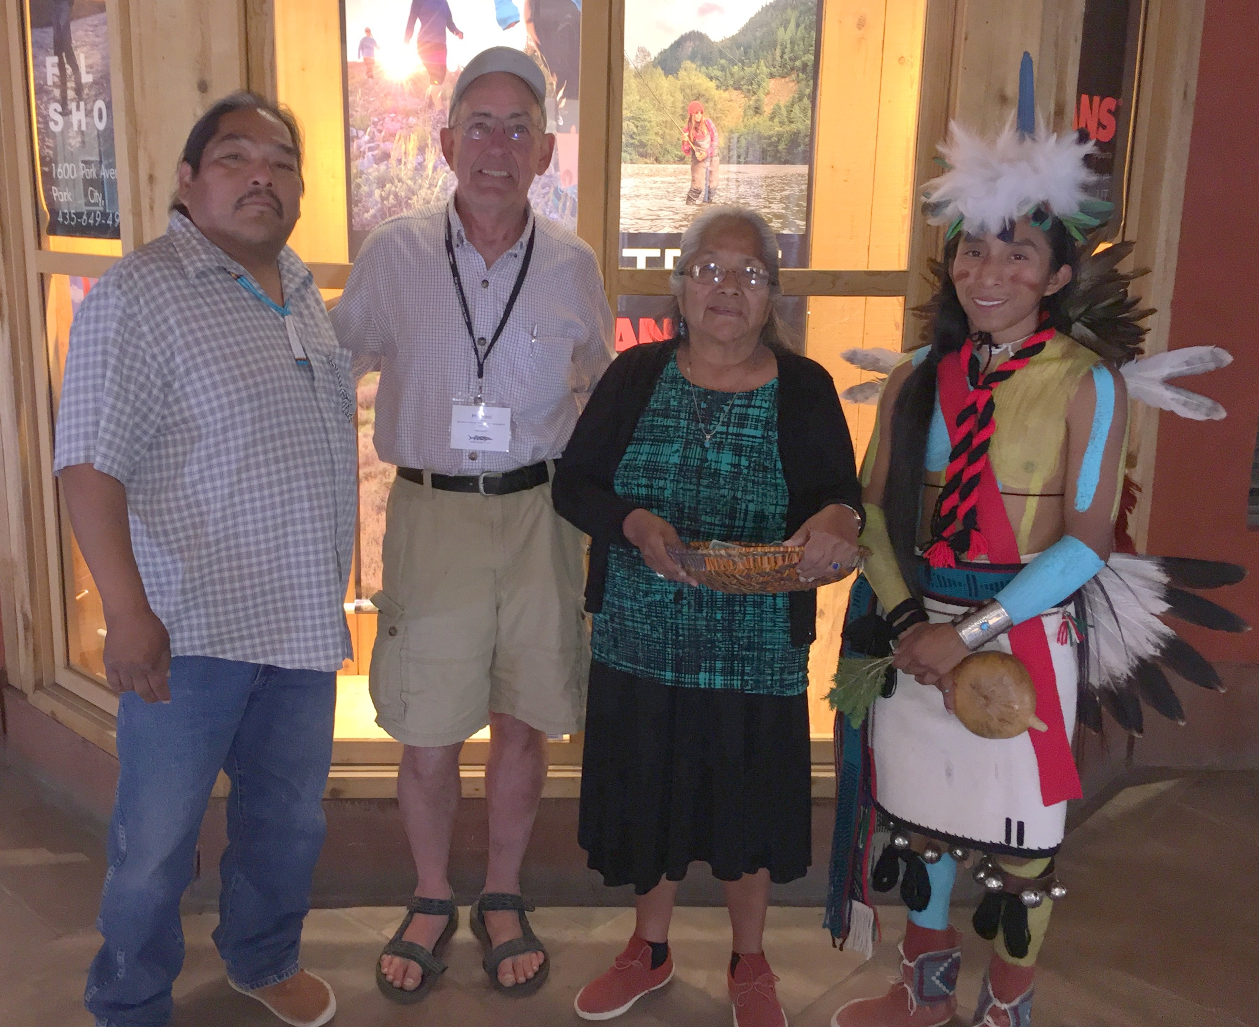

MEASURING FLOWS
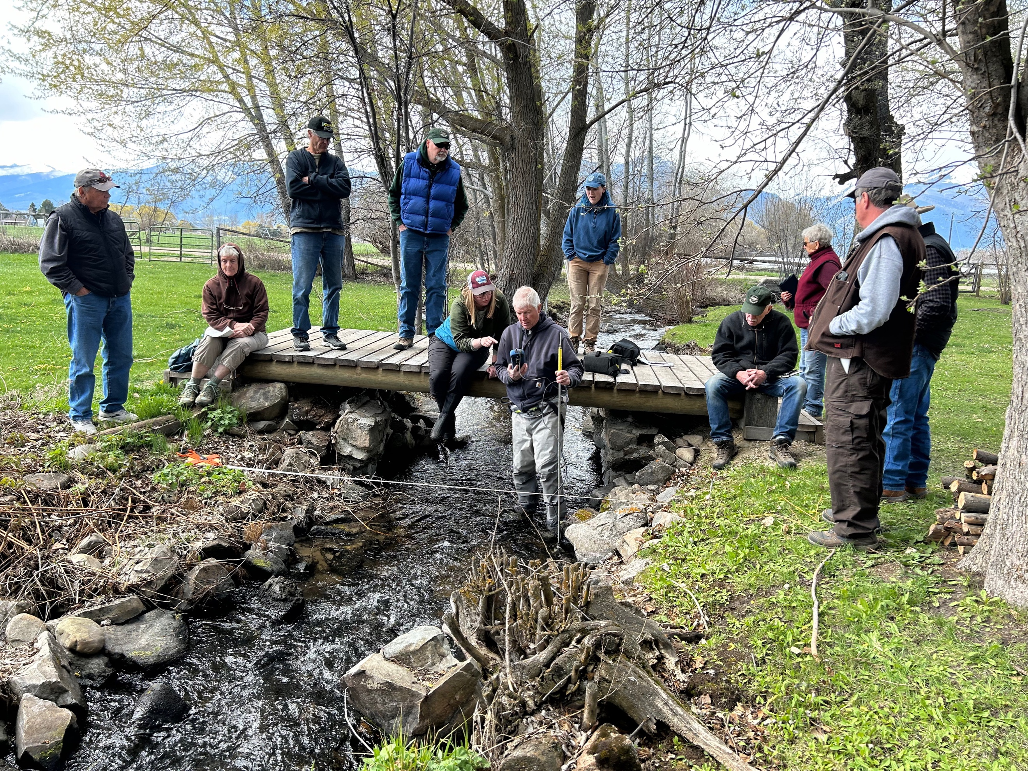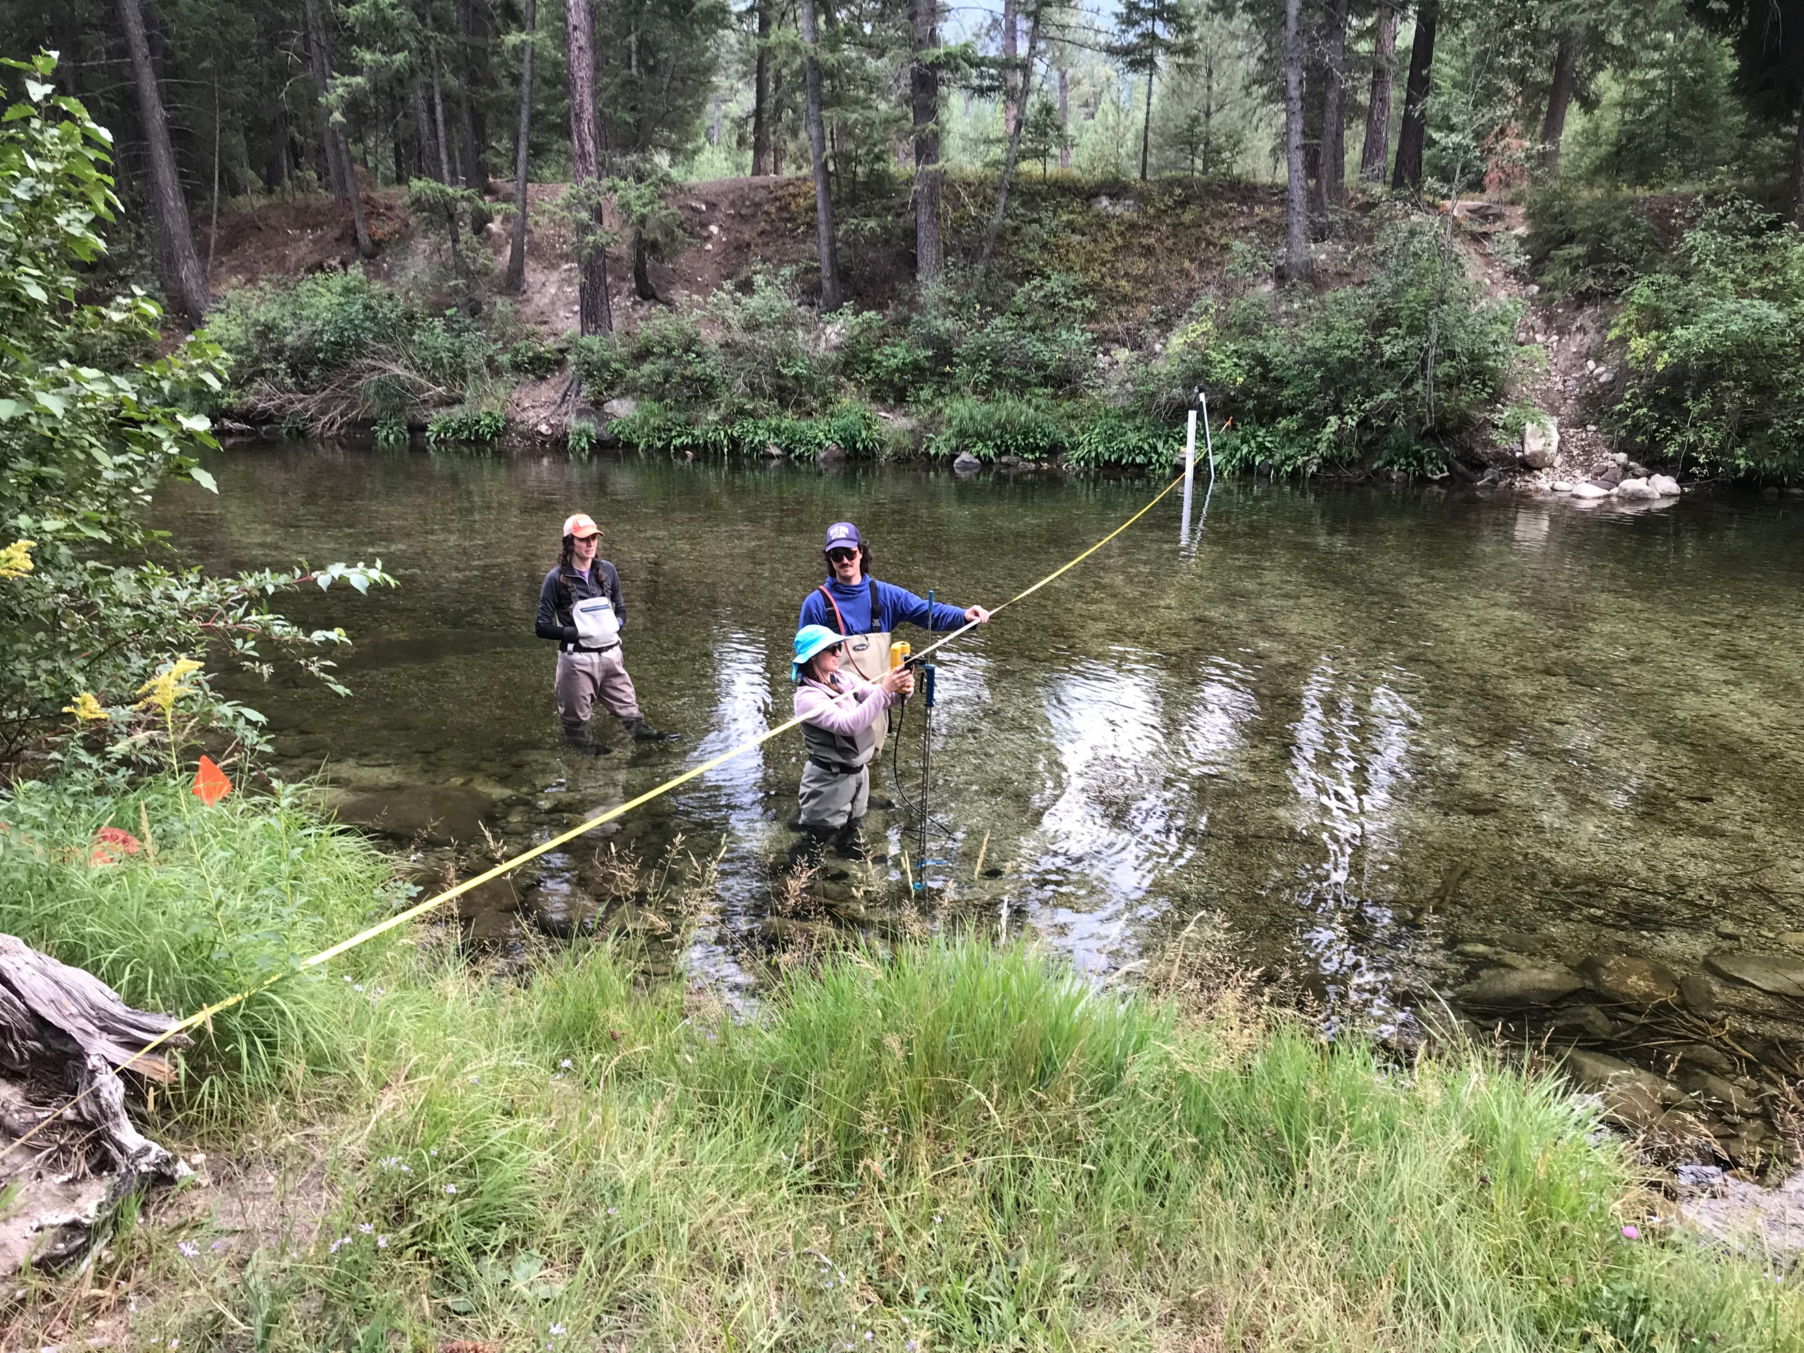

TAKING PHYSICAL PARAMETERS WITH A YSI GRABBINGG SAMPLES FOR LAB ANALYSIS
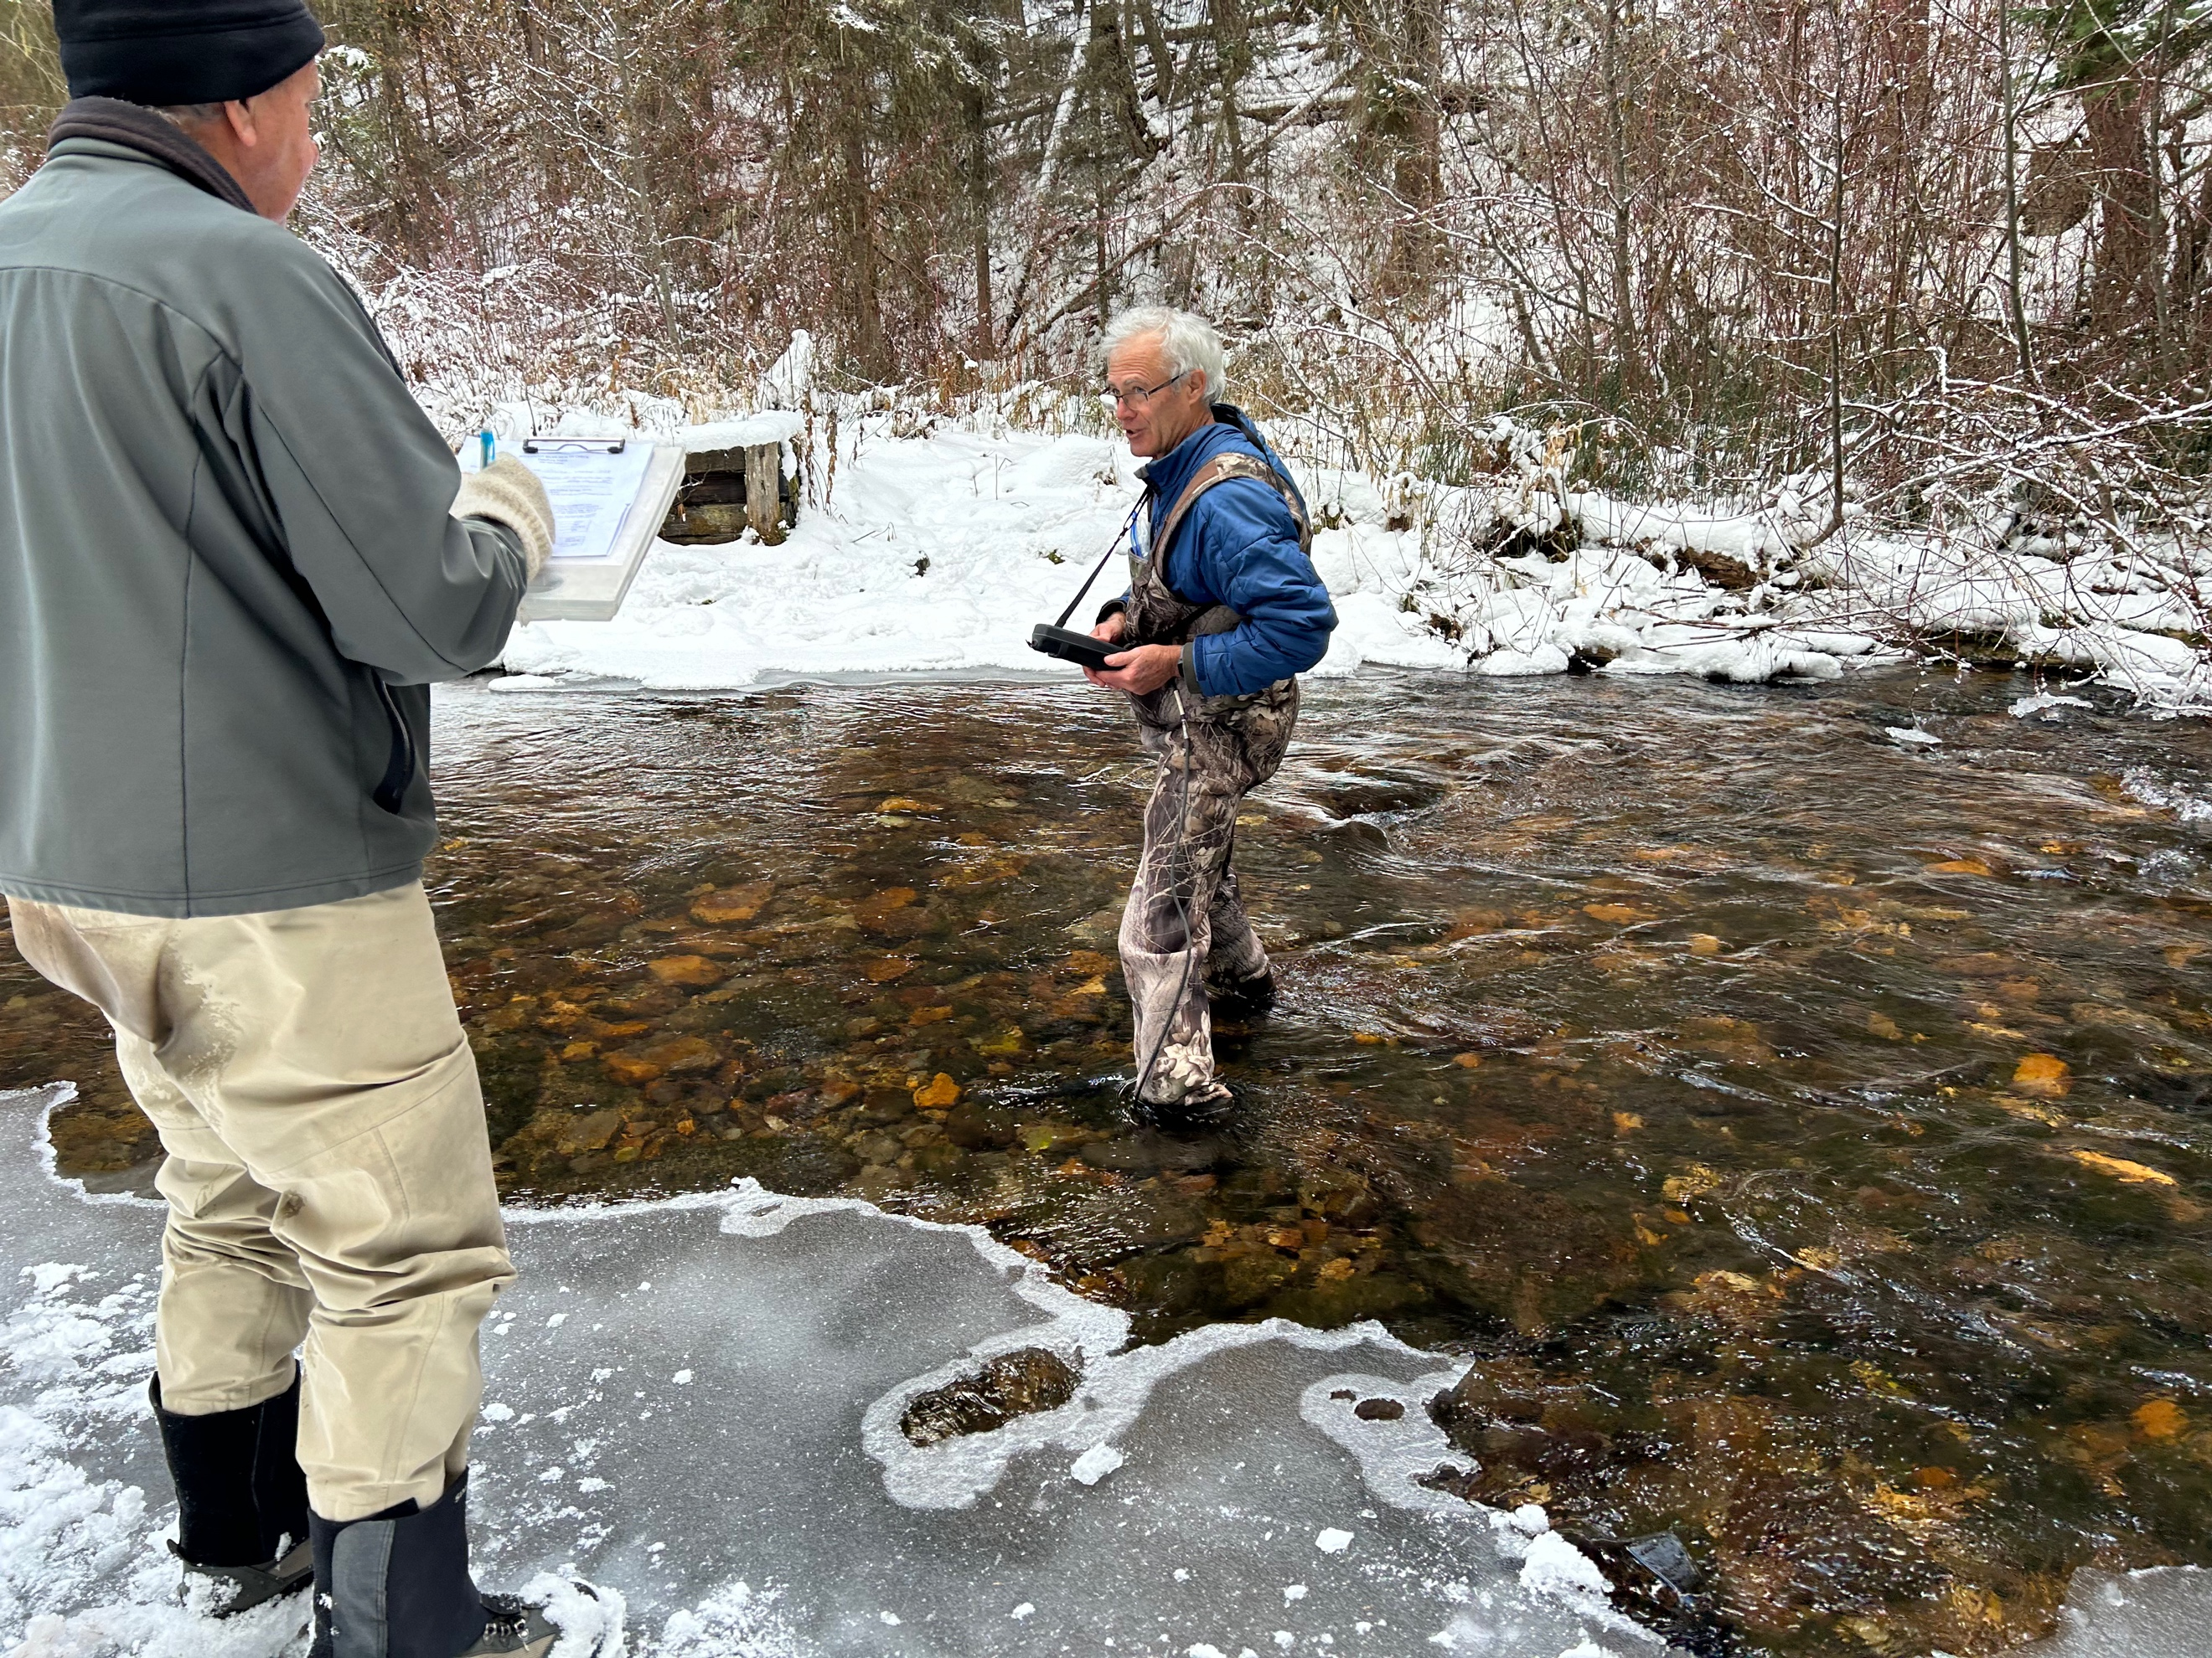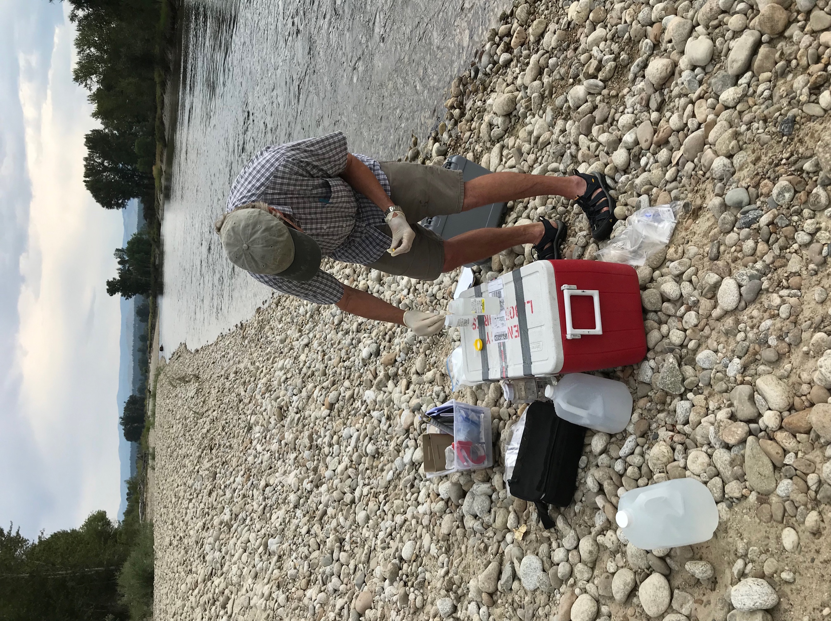

MEASURING ALGAE CONCENTRATIONS FROM ROCK SCRAPINGS
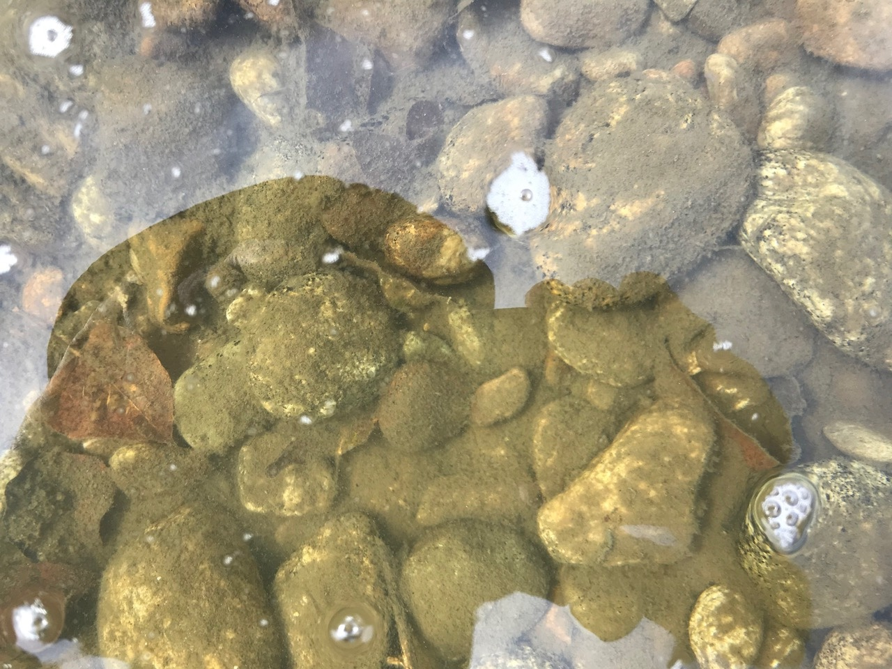
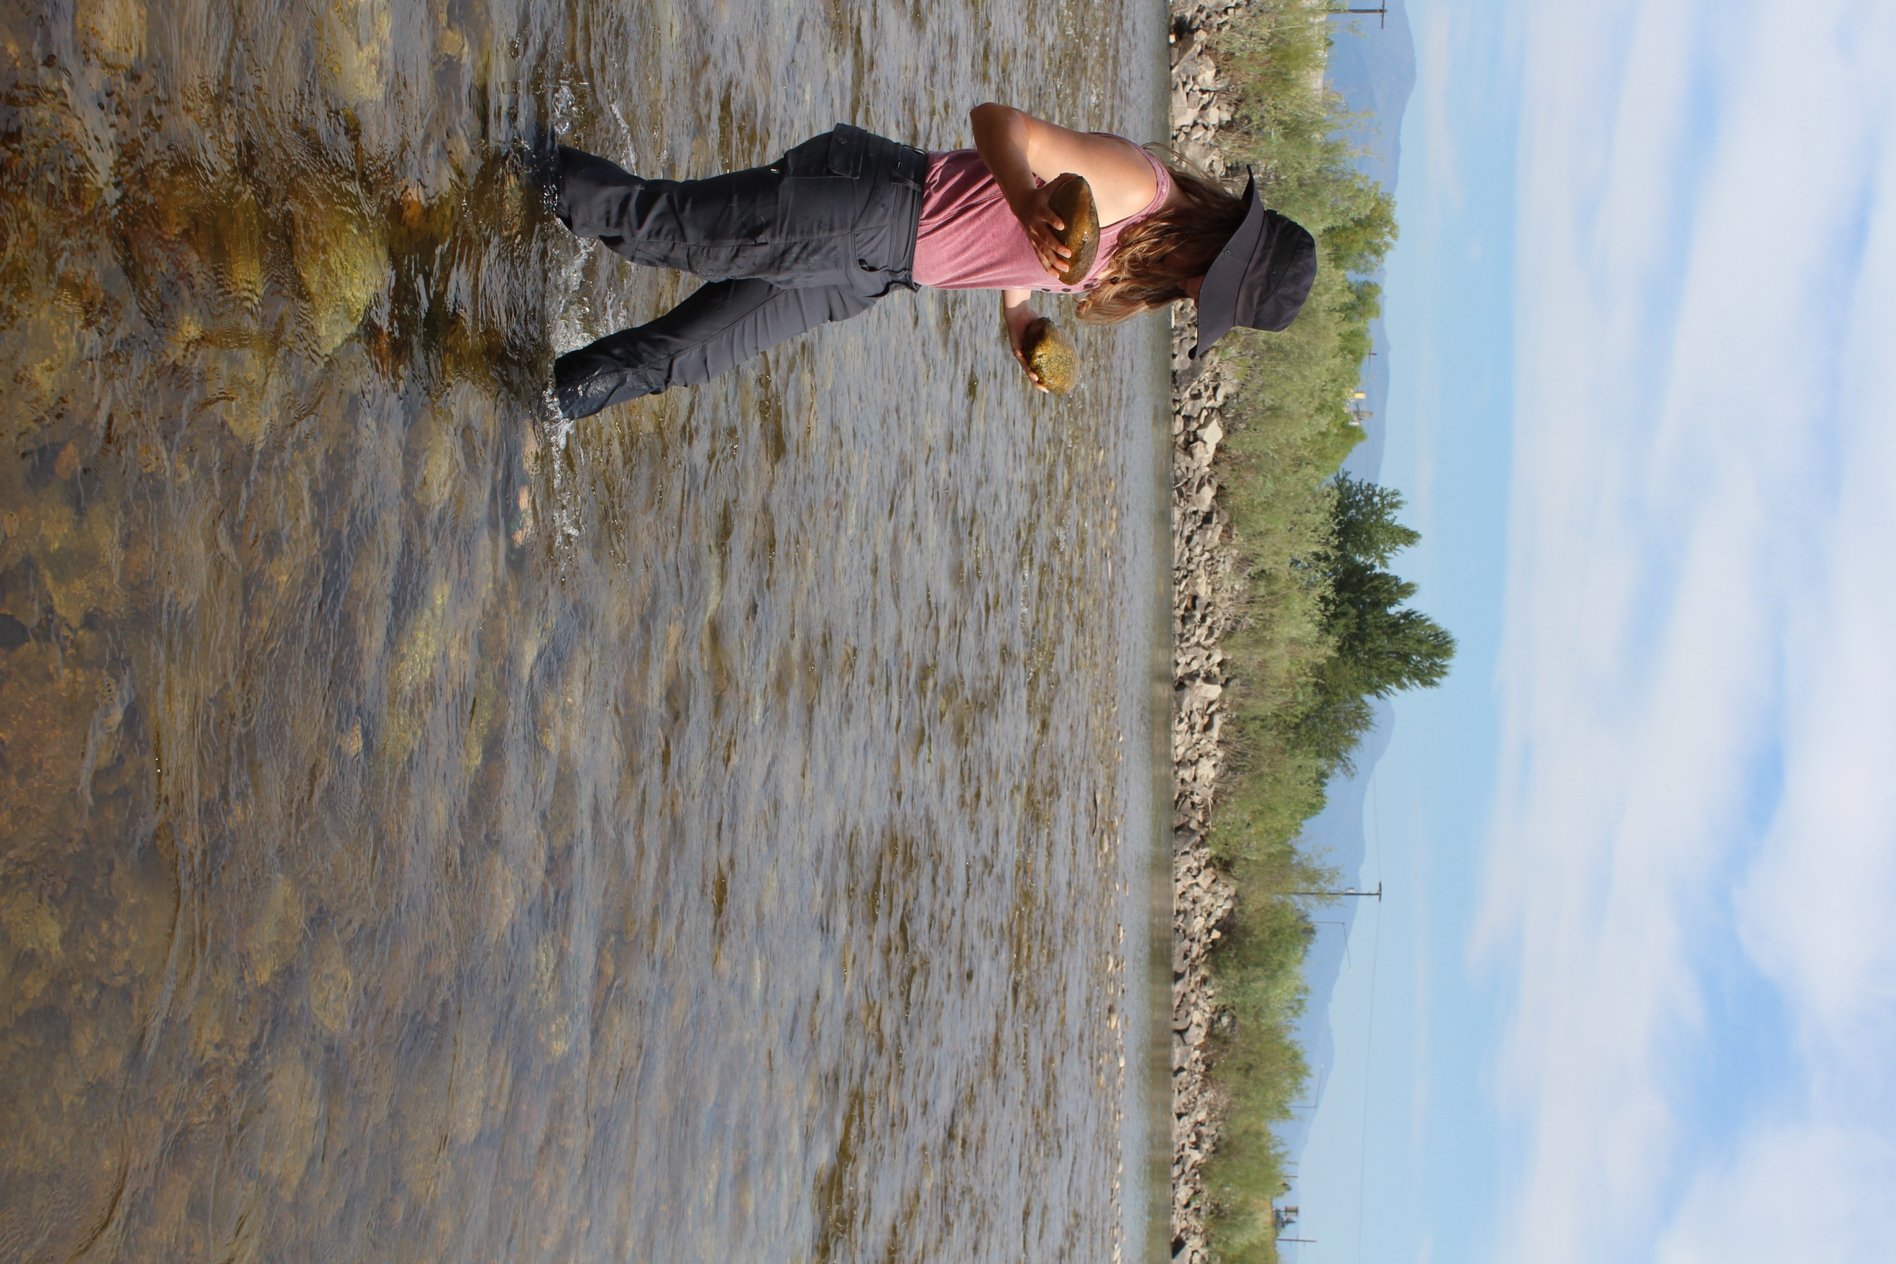
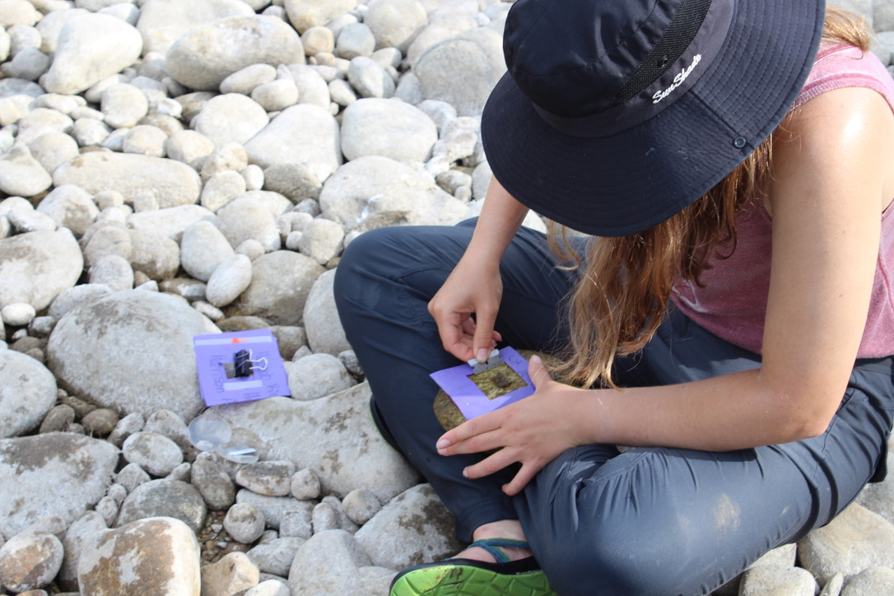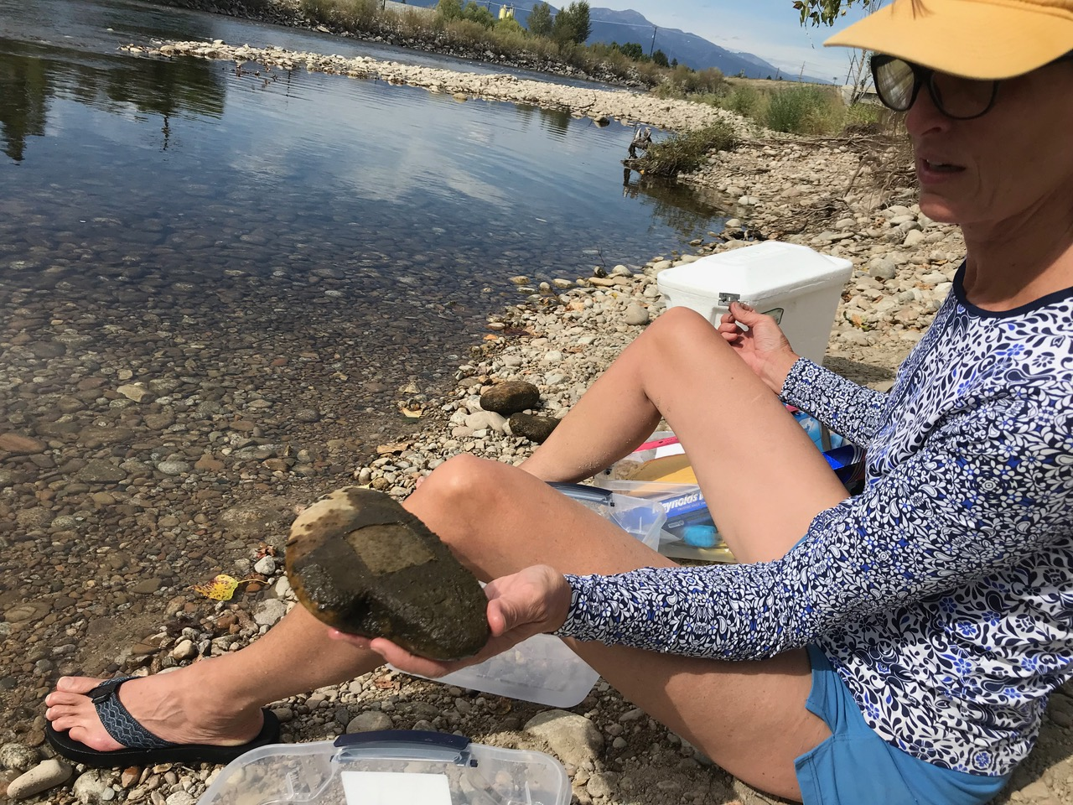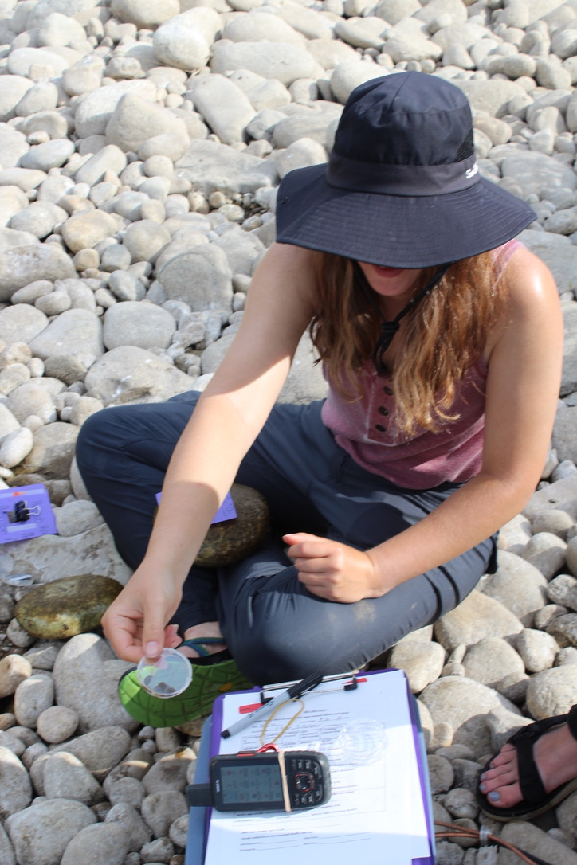

The Bitterroot River Protection Association is a 501(c)(3) non-profit and donations to the Bitterroot River Health Check program are tax deductible. Donations are spent on equipment, supplies, laboratory analysis and professional services when required.
If you wish to donate to the Bitterroot River Health Check program go to www.bitterrootriver.org, click on Bitterroot River Health Check and click the Donation Button or make your check out to: BRPA- Health Check and mail it to: BRPA- Health Check, P.O. Box 8, Stevensville, MT 59870.
For more information contact Michael Howell at (406)239-4838 or email bitterrootriverprotection@gmail.com

PROGRAM PARTNERS INCLUDE: 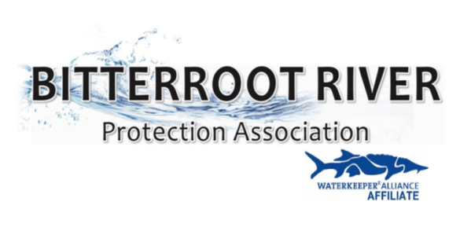 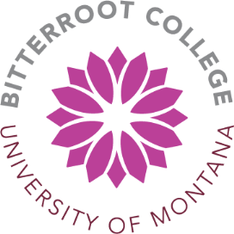

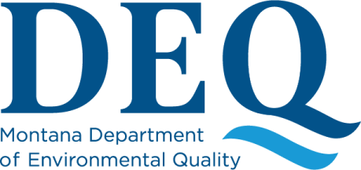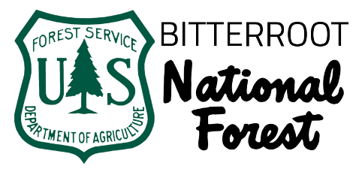

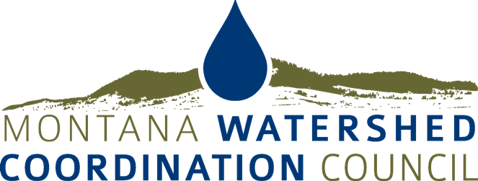

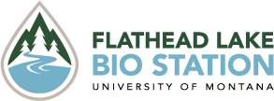

MAJOR DONORS
Put your business logo/link here

