Bitterroot River Protection Association
Bitterroot River West Fork Project
(Sheep Creek Mine)
Sampling and Analysis Plan

Insert Photo
Date: August 2025
Prepared by:
Michael Howell (Executive Director)
Bitterroot River Protection Association
BRPA
Bitterroot College
130 S. 9th St.
Hamilton, MT 59840

Table of Contents
Table of Contents 1
1.0 INTRODUCTION 1
1.1 Project Overview 1
1.2 Project Area Overview 3
1.3 Project Team and Responsibilities 4
2.0 Objectives and Sampling Design 5
2.1 Project Goals and Objectives 5
2.2 Monitoring Locations 6
2.3 Monitoring Schedule 8
2.4 Water Quality Parameters 8
3.0 Field Procedures 9
3.1 Order of Operations 9
3.2 Field Forms 11
3.3 Data Collection Standard Operating Procedures 11
4.0 Laboratory Analytical Requirements 13
5.0 Quality Assurance/Quality Control (QA/QC) 14
5.1 Overview 14
5.2 Training 14
5.3 QC Samples: Field Duplicates 14
5.4 QC Samples: Field Blanks 15
5.5 Instrument Calibration and Maintenance 15
5.6 Data Quality Indicators 16
5.7 Field Health and Safety 17
6.0 Data Management, Record Keeping & Reporting 18
6.1 DEQ’s MT-eWQX database and Data Quality Review 18
6.1.1 Project ID 18
6.2 Other Data Management Approaches 18
7.0 Data Analysis and Reporting 19
7.1 Data Analysis 19
7.2 Reporting 19
8.0 References 19
Appendix A - Project Budget 21
Appendix B – Field Forms 22
Appendix c – Equipment and supplies 30
Appendix D – QA/QC Terms and Definitions 31

Note: to update this table of contents, right click on it and select “update field” then “update entire table”.

1.0 INTRODUCTION

1.1 Project Overview
The Bitterroot River Protection Association is conducting this water quality monitoring in response to a proposed Rare Earth Elements (REE) mine at the headwaters of the Bitterroot River to establish a baseline for water quality in the area of the mine prior to any ground disturbing activity and serve as a foundation for continued monitoring in the area if the mining activity occurs.

In 2022 U. S. Critical Materials announced its intention to mine for Rare Earth Elements (REE) in its claims located in the Sheep Creek area of the upper West Fork of the Bitterroot River. Key property elements include neodymium and praseodymium. The project also includes cerium, dysprosium, europium, gadolinium, lanthanum, niobium, scandium, strontium, samarium, and gallium. Important ore minerals include ancylite, allanite, low-thorium monazite, and columbite. The property encompasses 336 lode claims representing approximately 10 square miles of total land package and the company asserts that initial exploration activities have identified more than 50 carbonatite dikes in the Sheep Creek district. The claims are on multiple-use ground administered by the U.S. Forest Service.

According to the Harvard International Review there are two primary methods for REE mining, both of which release toxic chemicals into the environment. Both methods produce mountains of toxic waste, with high risk of environmental and health hazards. For every ton of rare earth produced, the mining process yields 13kg of dust, 9,600-12,000 cubic meters of waste gas, 75 cubic meters of wastewater, and one ton of radioactive residue. This stems from the fact that rare earth element ores have metals that, when mixed with leaching pond chemicals, contaminate air, water, and soil. Most worrying is that rare earth ores are often laced with radioactive thorium and uranium, which result in especially detrimental health effects. Overall, for every ton of rare earth, 2,000 tons of toxic waste are produced.

According to the Kleinman Center for Energy Policy Regional ecosystems can be significantly altered by the presence of mines, both physically and chemically. Site preparation, access roads, and ancillary facilities lead to direct—and often absolute— destruction of the proximate environment, while pollution from mine processes and storage of residual tailings can lead to widespread chemical imbalances and toxic contamination.

REE mine tailings contain processing chemicals, salts, and radioactive materials. Tailings are particularly problematic in REE mining, because of the significant waste-to-yield ration. (Filho 2016; Xiang 2016). For every ton of REEs that are produced, there are 2,000 tons of mine tailings, including 1 to 1.4 tons of radioactive waste. Tailings are most commonly stored in isolated impoundment areas called tailing ponds. These ponds require complex management, especially if the tailings contain high concentrations of uranium or thorium. Poor construction or catastrophic failure can lead to long-term and widespread environmental damage and contamination of surface or groundwater (Filho 2016).

Other significant sources of pollution include aerosols and fugitive dust from tailing impoundments, which are created from cutting, drilling, and blasting rock. This pollution can accumulate in surrounding areas (Filho 2016), causing respiratory issues and also contaminating food sources—as plants absorb the airborne pollutants.
Another serious element of concern is actinolite. Unlike more commonly known asbestos types...actinolite often remains underestimated. Actinolite occurs in both fibrous and non-fibrous forms, but the fibrous type has garnered a reputation due to its links with asbestos. The health risks associated with this mineral cannot be overstated: Exposure to actinolite, particularly in environments where it is disturbed, poses significant respiratory health risks. The potential for mesothelioma, lung cancer, and other diseases expands with prolonged exposure.

Geologists at Montana Tech report that actinolite is one of the most common minerals in the host rock in the Sheep Creek area and the veinlets containing ore are "actinolite-rich." The Montana Bureau of Mines and Geology Crowley Bulletin reports actinolite at Sheep Creek “forms masses of radiating fibers surrounding other crystals.” The American Mineralogist, a prestigious industry journal, confirms: “actinolite forms clusters of fibers, usually in radiating groups.”

Given the high potential for toxic contamination that could result from this activity, the Bitterroot River Protection Association is conducting a water quality monitoring project in the upper West Fork of the Bitterroot River to establish a baseline for water quality in the area of the mine prior to any ground disturbing activity. It could serve as a foundation for continued monitoring in the area if the mining activity occurs This information may be used to identify any negative impacts related to the mining project at an early stage so that these impacts may be mitigated or eliminated as the mining proceeds. This will benefit the public by protecting the headwater streams, the West Fork and the Mainstem of the Bitterroot River from potential contamination by toxic metals (including potential radioactive contamination) and nutrients associated with REE mining operations. This, in turn will help protect not only the aquatic life and fisheries of the streams and the river in the upper West Fork but all the economic, recreational, and social values associated with the use of those waters.

This monitoring project fits into the ongoing mission (adopted in 2018) of BRPA, to establish a systematic set of long-term water quality/quantity monitoring stations throughout the Bitterroot River Watershed. As part of this mission, BRPA initiated monitoring on the mainstem in 2017-18. The success of these efforts led MT DEQ to adopt the Bitterroot River Long-Term Nutrient Monitoring program 2019-2039 which was funded for the first 10 years and is ongoing. In conjunction with DEQ’s program BRPA also began monitoring, on its own, six tributaries across the Sapphire Front at eleven locations in 2018-2024.

BRPA also has an ongoing permitting agreement with the Bitterroot Conservation District for establishing monitoring sites on and off the Forest in Ravalli County.

A budget table for laboratory analytical costs is included in Appendix A.

1.2 Project Area Overview
We will be collecting physical parameters and water samples at one site on the West Fork of the Bitterroot River below the claims proposed for development. We also plan to monitor one site near the bottom of Johnson Creek and one site at the bottom of Sheep Creek for a total of three sites. If the company submits a Plan of Operation and funding can be acquired additional sites may be added to the project.

The area is forested and primary land use has been forest management by the Bitterroot National Forest and past mining activity.

Two streams in the upper reaches of the West Fork with a history of mining activity and forest management have been listed for impairments in DEQ’s impaired stream list. These streams are located just down river from Johnson and Sheep Creeks.

Map of Project Area
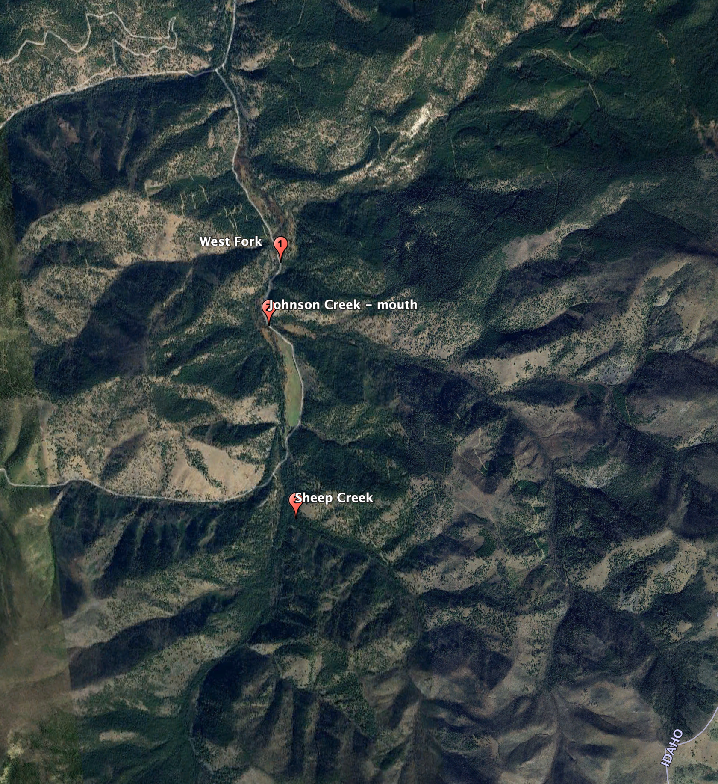

1.3 Project Team and Responsibilities

Table 1. Project Team Roles and Responsibilities
Role | Person(s) | Contact phone, email
Develop Sampling and Analysis Plan (SAP) | Michael Howell | (406) 239-4838 bitterrootriverprotection@gmail.com
Oversee monitoring personnel | Larry Campbell | lcampbell@bitterroot.net
Training monitoring personnel | MT DEQ and FLBS | Abbie Ebert(DEQ)  Abbie.Ebert@mt.gov  Dr. Rachel Malison (FLBS)  rachel.malison@flbs.umt.edu
Review field forms | Howell
Lab coordination (e.g., bottle orders, shipping notifications, lab EDDs) | Howell
Ship or deliver samples to lab | Larry
Review data quality | Howell
Upload data into MT-eWQX database | Howell
Write final report | Howell

2.0 Objectives and Sampling Design

2.1 Project Goals and Objectives
The goals for the project are manifold (Table 2). The data collected will be used to determine the present condition of the river streams with respect to the recommended ranges of nutrient and metal levels that protect beneficial uses, help establish a baseline for future comparisons and potentially determine long term trends within each stream. By doing both nutrient/metal sampling and flow measurements at the mouth of the streams we will be able to estimate the nutrient load and metal elements being delivered by each stream. Locating and calculating the loads being contributed from tributaries.

By gathering data below the mining claims we will be able to determine the amount of pollutants being contributed to the river from the area of the mining claims. This information would be valuable in determining a baseline for water quality in the area of the mine prior to any ground disturbing activity and serve as a foundation for continued monitoring in the area if the mining activity occurs.

The information gathered can also be used to educate the community about water quality. As these sites are intended to be monitored in perpetuity, the value of the data will increase over time and establish a baseline for drainage specific trends.

Table 2. Project Goals, Objectives and Analyses
Goal | Objective | Data Analysis
Evaluate current nutrient conditions in West Fork, Johnson Creek and Sheep Creek in the area of mining claims and establish a baseline for future comparisons. | To collect nutrient samples (Phosphorous, Orthophosphate as P and Nitrogen, Nitrate + Nitrite) at three sites in West Fork, the mouths of Johnson Creek and Sheep Creek in the proposed area of mining during low water | Compare nutrient concentrations in water against numeric nutrient standards in Montana Circular DEQ-12A and DEQ-7
 | To take photos of the stream substrate at each location and during each site visit where nutrient samples are being collected to visually document benthic algae conditions. | Visually estimate algae biomass at each site using guide in Montana DEQ's Chlorophyll-a SOP.
Evaluate current metal concentrations in the area of mining claims and establish a baseline for future comparisons. | To collect water and fine sediment samples (Lead, Arsenic and Selenium) at four sites in West Fork, the mouths of Johnson Creek and Sheep Creek in the proposed area of mining  during the spring and summertime growing season from May/June - September 30 | Compare metal concentrations in water against numeric nutrient standards in Montana Circular DEQ-15 and DEQ-7.
Evaluate Physical Parameters in the area of mining claims and establish a baseline for future comparisons. | To collect physical parameters for air and water temperature, Specific Conductance, barometric pressure, Dissolved Oxygen, pH, and turbidity at three sites in West Fork and the mouths of Johnson Creek and Sheep Creek in the proposed area of mining | Compare physical parameters against standards in Montana Circular DEQ-15 and DEQ-7

2.2 Monitoring Locations
Table 3. Monitoring Locations*
Site Name | Site Description | Station ID | Latitude | Longitude | Parameters to Collect | Rationale for Site Selection
West Fork A |  | BRWF-WestFk-bridge A | N45.543 905 | W114.316 333 | Physical, nutrient and metals | Below area of mining claims
Johnson Creek A |  | BRWF-JohnsonCr-MOUTH | N45.537 582 | W114.318 936 | Physical, nutrient and metals | Bottom of creek below mining claims
Sheep Creeek A |  | BRWF-SheepCr-down from road gate | N45.518 813 | W114.318 685 | Physical, nutrient and metals | Bottom of creek below mining claims
*These are proposed sampling locations which may change due to unforeseen access or other issues.

Also include a map showing your monitoring sites within your project area.
Insert site map
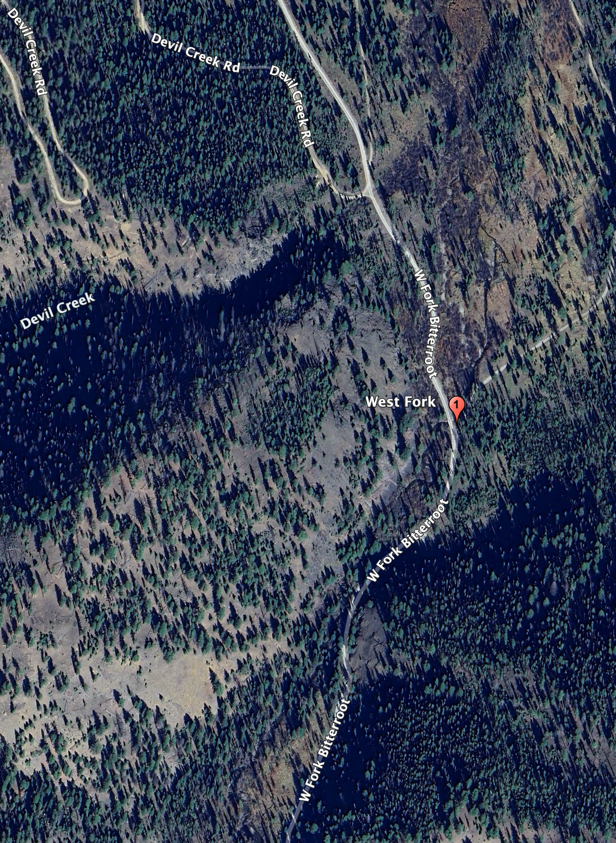
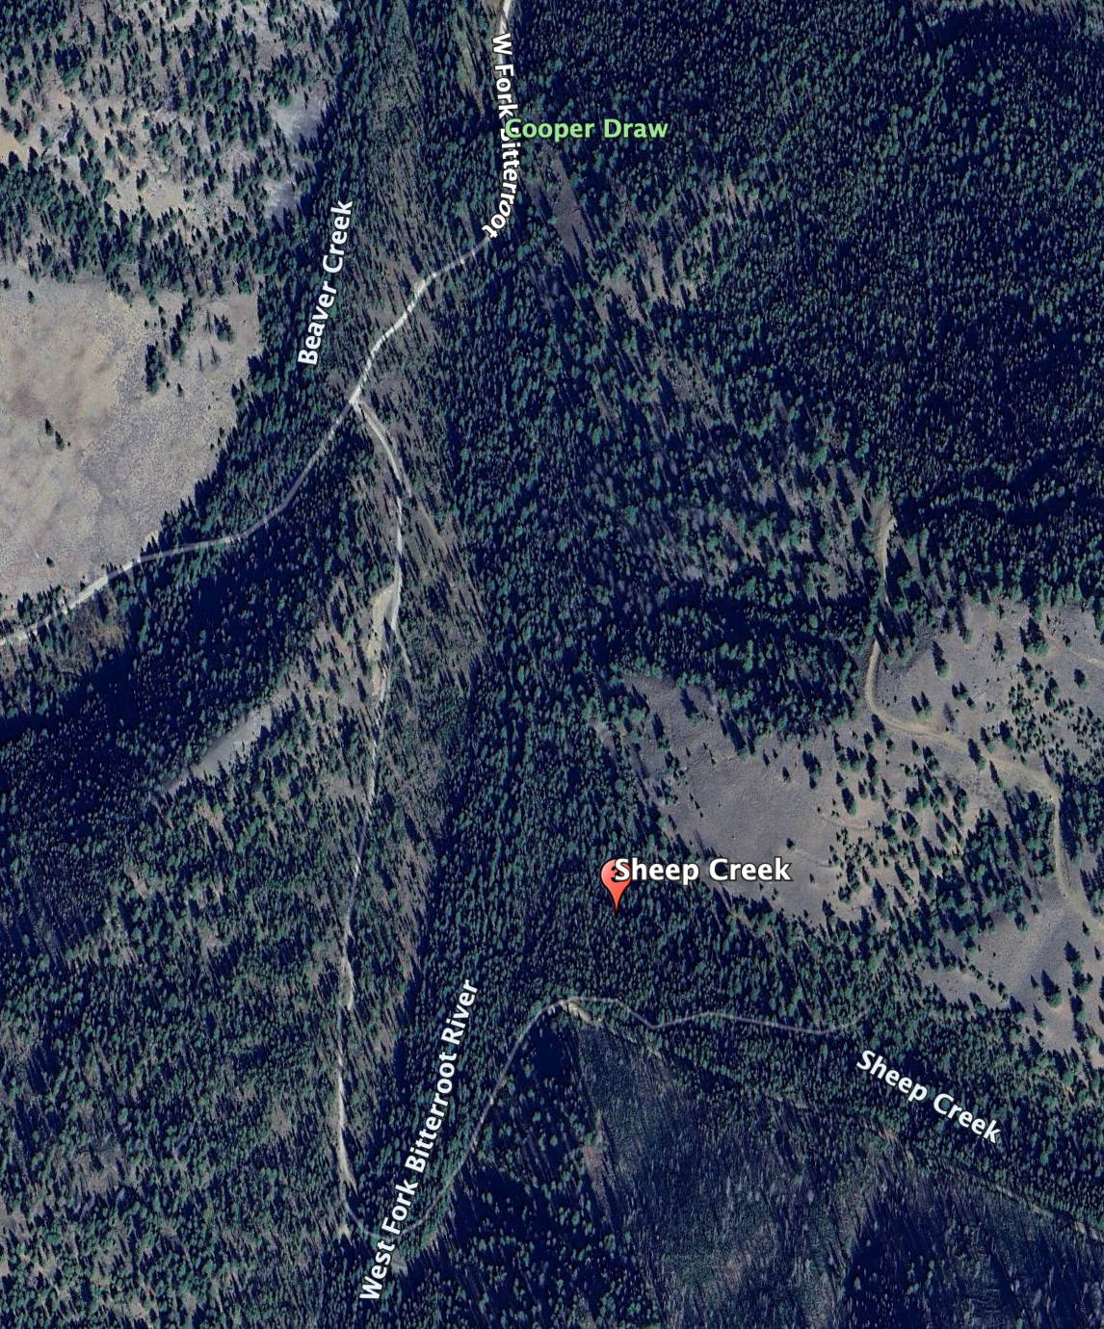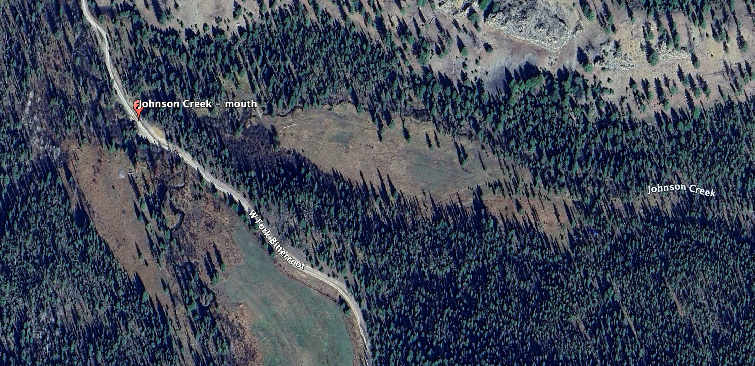

2.3 Monitoring Schedule
Monitoring will occur late summer/early fall.
Physical parameters will be collected at all three sampling sites
Nutrient/Metal Samples will be collected in September
- Table 4. Monitoring Schedule
Date | Parameters | Rationale for Timing
September | Physical, Nutrient, Metals, Flow | Base flow expected

2.4

Water Quality Parameters

Table 5. Water Quality Parameters
Parameter or Data Type | Collection Approach | Justification for Collecting
Nitrogen  Nitrite plus Nitrate (NO₂₊₃) N | Parameters measured via water samples analyzed by an analytical lab | Best simple nitrogen indicator
Phosphorous, Orthophosphate as P |  | Adds nutrient loading context
Metals by ICP/ICPMS, Total Reco. |  | Core test for metals including As, Pb, Se, Cd, Cr VI, Cu, Ni, Ag, Zn
Alkalinity to pH 4.5 |  | Asses buffering capacity for acid mine draining
Anions by Ion Chromatography |  | Includes fluoride and sulfate, relevant to REE mining
Hardness |  | No cost, useful context
Air & water temperature | Parameters measured in situ with YSI field meter | Common descriptive water quality parameter
Barometric pressure | Parameters measured in situ with YSI field meter | Common descriptive water quality parameter
pH | Parameters measured in situ with YSI field meter | Common descriptive water quality parameter
Water temperature | Parameters measured in situ with YSI field meter | Common descriptive water quality parameter
Specific conductance (SC) | Parameters measured in situ with YSI field meter | Common descriptive water quality parameter
Dissolved oxygen (DO) | Parameters measured in situ with YSI field meter | Common descriptive water quality parameter
Discharge (flow) | Measured with Global flow meter | Necessary to pair concentrations with flow data to calculate loads.
Photos | Taken with digital camera | Tracking riparian conditions, benthic algae conditions, and other site conditions; low-cost.

3.0 Field Procedures

3.1 Order of Operations
The Project Manager will prepare the appropriate sampling kits including all materials and equipment necessary and convey the equipment, coolers, and sampling supplies to each site and work with the appointed Volunteers at each site to perform the sampling. All sites are mapped and marked in situ with a colored ribbon. Volunteers are familiarized with the location in training. The following section references are to the BRPA Field Manual (see Appendix E).

At the site the order of operations is:
- Arrive at site and identify a “safe and good” location to perform sampling (Section 1).
- Turn on YSI meter, place in shade for 15 minutes (Section 4). Perform DO calibration at the first site of the day. Calibrate
- Fill out Site Visit Form with initial site information (name of site, ID, date, time of arrival and names of samplers (Section 2).
While the YSI is warming up other tasks may be performed serially or simultaneously (depending on how many volunteers are working at the site), as we move through the process of (a) photographing site (b) collecting nutrient and metal water and sediment samples (c) taking YSI readings (d) taking flow measurements and (d) making algae assessment.
- Once all the above activities are completed, volunteers pack up all equipment and proceed to remaining sites (if applicable).
- Any time samples are transferred from one person to another, indicate that they were relinquished and received by signing the COC form with date and time (Section 5).
- Return samples to storage location (Bitterroot College) and store samples in freezer according to sample preservation specifications (Section 4).
- Ship samples to analytical laboratory within specified holding times (Section 4).
After collecting data at one site, the Project Manager will maintain custody of the samples and relay everything to the next creek where he will meet the local volunteer and follow the same procedures at those two sites. At the end of the day the Project Manager returns all the samples and equipment to the laboratory at Bitterroot College and places all samples in either the refrigerator or the freezer, whichever is appropriate. Equipment is cleaned and stored at the lab.

Unfiltered Samples: Grab Technique

- Label the bottle using a permanent, fine-point marker to include the site ID, date collected, and time collected.
- Carry the bottle to a suitable sampling location:
- Sampler can safely wade and stand or access the water from a boat.
- Water column is well-mixed and deep enough to allow sampler to avoid surface scum and bottom sediments.
- Upstream or away from any disturbance to water column or bottom sediments.
- Triple-rinse the bottle and lid: face upstream into the direction of the flow, collect a small volume of water in the bottle, replace the lid, and shake gently. Discard the rinse water downstream. Repeat this process three times to triple-rinse.
NOTE: Do not rinse bottles that have preservatives added to the bottle prior to sampling (e.g., E. coli, mercury, and dissolved organic carbon sample bottles are often pre-preserved).
- Collect the sample:
- For wadable locations, submerge the bottle so the mouth is below the water surface but above the bottom and allow the bottle to fill.
- For lake surfaces (from a boat), submerge the bottle until the sampler’s elbow is at the water surface and allow the bottle to fill.
- Leave appropriate headspace:
- For most samples, the bottle should be filled to the shoulder or line that denotes the target volume; this will leave a small amount of head space, especially necessary if preservative will be added to the sample.
- If samples are to be frozen, leave sufficient head space to allow the sample to expand when it freezes without the bottle breaking.
- If samples require zero headspace (e.g., volatile organic analysis (VOA) or ultra-low-level mercury (ULL-Hg)), submerge the container and lid, remove the lid, allow to fill completely, and secure the lid, all while submerged; verify there is no head space or air bubbles; if head space or air bubbles remain, use the lid to add a small amount of water until a convex meniscus (slight bulge of water surface) forms, then secure the lid.
- If preservative is required to be added to the sample, put on gloves, carefully unscrew the lid, pour the entire contents of the preservative vial into the sample bottle, replace the lid, and gently invert the sample bottle three times to mix the preservative into the sample. Discard the empty preservative vial.
- Store samples upright according to sample preservation and storage requirements (e.g., in a cooler on regular ice at ≤6ºC, or frozen on dry ice).
- Deliver samples to the analytical laboratory within required holding times.

Filtered Samples: Grab Technique

- Label the bottle using a permanent, fine-point marker to include the site ID, date collected, and time collected.
- Carry the bottle, filter and syringes to a suitable sampling location:
- Sampler can safely wade and stand or access the water from a boat.
- Water column is well-mixed and deep enough to allow sampler to avoid surface scum and bottom sediments.
- Upstream or away from any disturbance to water column or bottom sediments.
- Remove a clean 60 cc syringe from the provided Ziploc bag. Triple-rinse syringe by drawing ambient (stream or lake) water into the syringe, gently shaking, and compressing the syringe to force the water out; repeat this three times.
- Open a new 0.45 µm filter package by gripping the ring and peeling the cover open. Screw the filter onto the syringe and discard the packaging. Plunge ambient water through the filter to “prime” the filter.
- Triple-rinse the sample bottle with filtered water: plunge a small amount of water (approximately 10-20ml) from the syringe through the filter into the sample bottle. Replace the lid, shake gently, and then discard the rinse water downstream. Repeat this process three times to triple-rinse the bottle with filtered water.
NOTE: Do not rinse bottles that have preservatives added to the bottle prior to sampling (e.g., E. coli, mercury, and dissolved organic carbon sample bottles are often pre-preserved).
- Collect the sample: fill the bottle with filtered water. Often, to fill the bottle will require multiple refills of the syringe; when the syringe is empty, grip the filter’s ring, unscrew the filter and refill the syringe, taking care not to contaminate the filter. If the filter is not clogged, screw the filter back onto the syringe and continue filtering until the bottle is sufficiently full. If the filter clogs mid-way throughout filtering, unscrew and discard the clogged filter, refill the syringe, screw on a new filter, pass a small amount of water through the new filter, and continue filtering. Repeat this process until the sample bottle is full.
- Leave appropriate headspace:
- For most samples, the bottle should be filled to the shoulder or line that denotes the target volume; this will leave a small amount of head space, especially necessary if preservative will be added to the sample.
- If samples are to be frozen, leave sufficient head space to allow the sample to expand when it freezes without the bottle breaking.
- If samples require zero headspace (e.g., volatile organic analysis (VOA) or ultra-low-level mercury (ULL-Hg)), submerge the container and lid, remove the lid, allow to fill completely, and secure the lid, all while submerged; verify there is no head space or air bubbles; if head space or air bubbles remain, use the lid to add a small amount of water until a convex meniscus forms, then secure the lid.
- If preservative is required to be added to the sample, put on gloves, carefully unscrew the lid, pour the entire contents of the preservative vial into the sample bottle, replace the lid, and gently invert the sample bottle three times to mix the preservative into the sample. Discard the empty preservative vial.
- Store samples upright according to sample preservation and storage requirements (e.g., in a cooler on regular ice at ≤6ºC)
- Deliver samples to the analytical laboratory within required holding times.

3.2 Field Forms
BRPA’s Site Visit Form
- Chain of Custody Form
- YSI Calibration Form
- Total Discharge Form
- DEQ Algae Visual Assessment Form

Copies of field forms are included in Appendix B.

3.3 Data Collection Standard Operating Procedures

We are using a YSI ProDSS meter for collecting physical parameters including temperature, barometric pressure, specific conductance, pH, dissolved oxygen, total dissolved solids and turbidity. The instrument specifications can be found in Appendix C. It is calibrated monthly and DO calibration is performed every day of use. The calibration work sheet can be found in Appendix B and the DO calibrations are contained in a report book that accompanies the meter.

Prior to data collection, the BRPA or MCWQD will calibrate a YSI DSS or Pro Plus meter according to instructions in the user manual. During each sampling event at each sampling site, in situ measurements of field parameters and turbidity will be conducted using a YSI ProDSS or Pro Plus meter (Section 2.0). These measurements must be taken prior to collecting water quality samples or other physical disturbances to the water column and substrate. The results of the field measurements will be recorded on routine site visit forms for each monitoring station.

The following steps will be followed to collect instantaneous measurements using the YSI meter:
1. Remove the YSI meters from its case, attach the cable to the handheld unit if not already connected, and turn the instrument on.
2. Place a thermometer in a shaded location and allow it to equilibrate. When stable, record the air temperature on the Routine Site Visit Form.
3. The ODO sensor must be calibrated at the start of each sampling day. Place a small amount of clean water (~5 ml) in the calibration cup. Make sure there are no water droplets on the ODO sensor cap or temperature sensor. Attach the probe guard and carefully slide the assembly into the calibration cup. Make sure a seal is not created around the probe. Atmospheric venting is required for accurate calibration.
4. Place the meter in a safe place in the shade with the unit turned on and with ODO calibration selected, then allow the meter to sit undisturbed for approximately 10- to 15-minutes. This allows the barometric pressure to stabilize and calibrates the meter in preparation for DO readings at each site. When the DO reading is stable, accept ODO calibration.
5. Wade with the meter into a safe location of the stream. Field measurements should be taken at a location that is well-mixed, has steady flow, is not excessively turbulent, stagnant or in an eddy, and is free of upstream obstructions and disturbances (for example, not directly downstream from a bridge, boulder, tree, people, dogs), and deep enough so the sensor can be entirely submerged.
6. Facing upstream into the direction of flow, fully submerge the probes. Take care not to kink the cable. If the river bottom is very fine silt or mud, hold the sensors above the river bottom so the sensors are suspended above and not buried in sediment. Gently swirl and shake the sensors to release any air bubbles that are trapped in the sensor guard.
7. Observe the display screen and wait a minute or more until the numbers stabilize. NOTE: It is permissible to collect the Nutrient Grab Samples (Section 3.3) while allowing the probes to equilibrate, but care must be taken to place the probes upstream from where the samples will be collected to avoid any disturbances. 8. Record the field parameter values on the Routine Site Visit Form, carefully noting the units. Finally, log the values on the YSI handheld, taking care to select the correct sampling site.

We use a Global Flow meter for measuring flows. Specifications can be found in Appendix C. We follow MT DEQ SOPs for taking flow measurements (See Standard Operating Procedure Total Discharge WQDWQPBFM-03, Version 1.0 and FLBS Sample Collection Standard Operating Procedures)

We follow MT DEQ’s Standard Operating Procedures for collecting water samples (See: Standard Operating Procedure Sample Collection for Chemistry Analysis: Water, Sediment, and Biological Tissue. WQDWQPBFM-02, Version 1.0 )

We take three photos at each site Upstream, Across and Downstream showing banks and littoral vegetation. We also take photos of streambed and algae and document visual assessments according to MT DEQ’s SOP for making visual assessments. (See: Sample Collection and Laboratory Analysis of Algal Chlorophyll-a, Ash Free Dry Weight, and Aquatic Plant Visual Assessment Standard Operation Procedure WQPBWQM-011, Version 9.0)
Photos are saved under a naming format and archived digitally.

4.0 Laboratory Analytical Requirements
Table 6. Monitoring Parameter Suite, Sample Handling, Analysis & Preservation

Parameter | Preferred Method | Required Report Limit (mg/L) |  | Holding  Time (days) | Required Bottles | Preservative
Phosphorous, Orthophosphate as P | EPA 365.1 | 0.005 |  | 48 hours | 120 ml | Cool on ice in field (freeze if need be)
nitrate + nitrite nitrogen (NO2+NO3-N) | E353.2 | 0.01 |  |  | 250 ml | H2S04
Anions by Ion Chromatography | E300.0 | Flouride | 0.1 |  | 500 ml | Cool on ice in field (freeze if need be)
Anions by Ion Chromatography | E300.0 | Sulfate | 1 |  | 500 ml | Cool on ice in field (freeze if need be)
Alkalinity to pH 4.5 | A2320 B | Alkalinity, Total as CaCO3 | 4 |  |  | Cool on ice in field (freeze if need be)
Alkalinity to pH 4.5 | A2320 B | Bicarbonate as HCO3
Alkalinity to pH 4.5 | A2320 B | Carbonate as CO3
Chromium, Total Hexavalent | A3500-Cr B | 0.01 |  | 24 hours | 250 ml
Hardness | A2340 B | Hardness as CaCO3. 1 | 1 |  | 250 ml | HNO3
Metals Digestion by E200.2 | E200.2 |  |  |  | 250 ml | HNO3
Metals by ICP/ICPMS, Total Recoverable | EPA  200.7_8 |  |  |  | 250 ml | HNO3
Arsenic |  | 0.001 |  |  | 250 ml | HNO3
Cadmium |  | 3E-05 |  |  | 250 ml | HNO3
Calcium |  | 1 |  |  | 250 ml | HNO3
Copper |  | 0.002 |  |  | 250 ml | HNO3
Lead |  | 0.0003 |  |  | 250 ml | HNO3
Magnesium |  | 1 |  |  | 250 ml | HNO3
Nickel |  | 0.02 |  |  | 250 ml | HNO3
Selenium |  | 0.01 |  |  | 250 ml | HNO3
Silver |  | 0.0002 |  |  | 250 ml | HNO3
Zinc |  | 0.008 |  |  | 250 ml | HNO3

5.0 Quality Assurance/Quality Control (QA/QC)

5.1 Overview
Projects require adequate documentation, proper sample collection, handling, and analysis, and other measured to produce high quality, credible data that accurately represent conditions in the watershed and can be used to answer scientific questions or guide resource management decisions.

Quality Assurance (QA) is the overall system used to ensure a monitoring project produces data of the desired level of quality necessary to meet project goals and objectives. For example, QA activities include developing a sampling and analysis plan, properly training volunteers, communicating analytical requirements to the lab, and adhering to standard operating procedures.

Quality control (QC) are technical activities used to detect and control errors. For example, QC activities include collecting field duplicates, preparing field blanks, reviewing field forms for accuracy, and calibrating equipment. Good QC will help to identify problems with the data if they arise and help identify what the cause of the problem likely is.

A list of QA/QC terms and definitions is included in Appendix C.

5.2 Training
All program participants will attend a monitoring training/refresher course in which protocols are reviewed by the program leader and/or water quality professionals. Each participant will be provided with and asked to review this sampling and analysis plan (SAP), the Standard Operating Procedures(SOP) (op. cite), field forms and BRPA Field Manual before sampling commences, and must have copies of both SAP and Field Manual with them in the field during all sampling events for reference. A program leader or alternate experienced volunteer will accompany each volunteer during sampling events at least until they demonstrate proficiency.

5.3 QC Samples: Field Duplicates

Field duplicates are two samples (i.e., a routine sample and a duplicate sample) of ambient water collected from a waterbody as close as possible to the same time and place by the same person and carried through identical sampling and analytical procedures. Field duplicate samples are labeled, collected, handled and stored in the same way as the routine samples and are sent to the laboratory at the same time.

Field duplicates are typically collected at a rate of approximately 10% of the total number of routine samples collected. Therefore, to achieve this, one set of field duplicates will be collected during each sampling event. Duplicates may be collected at any of the monitoring locations shown in Section 2.2. See Section 3.4 for information about duplicate sample labeling and Section 4.0 for analytical requirements.

Field duplicates are used to determine field precision to ensure that proper procedures are followed consistently. For each field duplicate set collected, the relative percent difference will be calculated:
Relative Percent Different (RPD) = ((D1 – D2) / ((D1 + D2)/2)) x 100
where: D1 = routine sample result value
D2 = duplicate sample result value

Precision will be assessed by ensuring that relative percent difference (RPD) between duplicates is less than 25%. If the RPD of field duplicates is greater than 25% and the parent and duplicate result values are greater than five times the lower reporting limit, the result values will be flagged with a “J”.

5.4 QC Samples: Field Blanks

Field blanks are samples of analyte-free, laboratory-grade deionized water poured into a sample container in the field using the same method, container, and preservation as routine samples, and shipped to the lab along with other field (i.e., routine and duplicate) samples. All labeling, rinsing, preservation, and storage requirements applied for routine and duplicate samples are applied to field blanks; the only difference is that the water is deionized water rather than ambient stream water. Field blanks must be prepared while in the field.

One set of field blanks is submitted to the laboratory with each batch of samples delivered to the laboratory. Therefore, one set of field blanks will be prepared at or near the end of each monthly sampling event and submitted to the laboratory alongside the other routine and duplicate samples from that trip. See Section 3.4 for information about field blank sample labeling and Section 4.0 for analytical requirements.

Field blanks are used to determine the integrity of the field personnel’s handling of samples, the condition of the sample containers supplied by the laboratory, and the accuracy of the laboratory methods. Accuracy will be assessed by ensuring that field blanks return values less than the lower reporting limit (i.e., non-detects) (shown in Section 4.0). If an analyte is detected in a field blank, all result values for that analyte from that batch of samples associated with the field blank will be qualified with a “B” flag. The exception is that data with a value greater than 10 times the detected value in the blank does not need to be qualified.

5.5 Instrument Calibration and Maintenance
Our YSI meter is calibrated regularly once a month and more often if the need arises. The DO is calibrated prior to use at all sampling events. Calibration and maintenance procedures are found in the YSI ProDSS User Manual found online at www.YSI_ProDSS_User_Manual_English.pdf

Flow meters do not require calibration, but operation and maintenance procedures are found in the user manuals.
FlowTracker2- https://www.geotechenv.com/Manuals/SonTek_Manuals/sontek_flowtracker2_manual.pdf
Global Water Flow probe- https://www.ysi.com/File%20Library/Documents/Manuals/FP111-Flow-Probe-User-Manual.pdf?srsltid=AfmBOopJU-Cx4fB4r1yKBcGvJs5fSXkVdKz2ZEMT148HcwyE_DeBEeNK

5.6 Data Quality Indicators

Data quality indicators (DQIs) are attributes of samples that allow data users to assess data quality. Because there are large sources of variability in streams and rivers, DQIs are used to evaluate the sources of variability and error and thereby increasing confidence in our data.

This section describes how the sampling and analysis plan and study design aims to achieve data quality for each data quality indicator (representativeness, comparability, completeness, sensitivity, precision and accuracy).

Representativeness
Representativeness refers to the extent to which measurements represent an environmental condition in time and space.

Spatial representation
The monitoring site on the West Fork of the Bitterroot River was chosen below the mining claims to capture data in water quality as it exits the area of mining. Site locations on the streams were chosen near the mouth of the streams to determine the total amount of pollution being contributed to the river. All the sites are located on the Bitterroot National Forest and permitted by both the agency and the Bitterroot Conservation District.

Temporal representation
Sampling will be conducted from downstream to upstream to ensure that the same water is not being sampled twice and so field crews are not disturbing the sampling locations. All sites will be sampled on the same day. Flow monitoring will occur in conjunction with chemistry sampling to help ensure comparable conditions.
Comparability
Comparability is the degree to which methods, data, or decisions are similar. Comparability expresses the confidence with which one data set can be compared to another. To achieve a comparable result, both the field collection method and the analytical method must be comparable.
We are following MT DEQ’s Standard Operating Procedures and are collecting the same data for the most part as collected by our organization elsewhere in the watershed over the past seven years using the same analytical methods, holding times, sample containers, and reporting limits as previous monitoring efforts, although we have added metal analytes to this project to address specific concerns in this area over proposed mining activities. We will be using Energy Labs which is an accredited laboratory.
Completeness
Completeness is a measure, expressed as a percentage, of the amount of data that you planned to collect compared to the amount of data that you actually collected.
We have scheduled a total of one sampling event at three sites and our completeness goal is to complete at the very least 90%. We hope to reach this completeness goal by following the theses directives: Prior to leaving a sampling site, field forms will be reviewed by the field leader on site to reduce the occurrence of empty data fields. Samples that are damaged within a short amount of time after collection will be recollected. Lab reports will be reviewed upon receipt to ensure that results for each sample submitted are received.
Sensitivity
Sensitivity refers to the limit of a measurement to reliably detect a characteristic of a sample. Related to detection limits, the more sensitive a method is, the better able it is to detect lower concentrations of a variable; for analytical methods, sensitivity is expressed as the method detection limit (MDL).

Detection and reporting limits are specified for this project which are adequately low enough to enable comparison to the thresholds of interest (e.g., numeric nutrient standards). The laboratory routinely checks sensitivity (e.g., method blanks, continuing calibration blanks, and laboratory reagent blanks) per their quality management plan.

Precision, Bias, and Accuracy
Bias is the degree of systematic error in an assessment or analysis process; when bias is present, the sampling result value will differ from the accepted, or true, value of the parameter. Adhering to standard operating procedures during sampling will reduce sampling bias.

Precision measures the level of agreement or variability among a set of repeated measurements obtained under similar conditions. Field duplicates (Section 5.3) will be collected during this project and used to determine field precision. If problems are linked to field crew sampling error, supplemental training will be provided prior to the next sampling event.

Accuracy is the extent of agreement between an observed value (sampling result) and the accepted, or true, value of the parameter being measured. A field blank (Section 5.4) will be prepared during this project and used to evaluate accuracy for field activities. The laboratory uses EPA approved and validated methods and performs precision and accuracy performance evaluations per their quality management plan.

Holding Time
All samples will be checked to verify that they were processed within their specified holding times. Sample results whose holding time was exceeded prior to being processed will be qualified with an “H” flag.

5.7 Field Health and Safety
Field personnel commonly encounter hazards while performing monitoring activities. All participants are advised to take adequate precautions to avoid injury or loss of life due to hazards including, but not limited to, driving, wading and other activities in and around water, weather conditions, wildlife interactions, people interactions, use of chemical preservatives, etc.

On every sampling trip, field personnel should carry with them a communication device (e.g., cell phone), first aid kit, bear spray, adequate drinking water, clothing appropriate for a range of weather conditions, personal protective equipment including waders, adequate footwear, and gloves to be worn while handling preservatives, and any other necessary safety-related items.

Each volunteer will be required to sign a waiver acknowledging risk and these waivers will be kept on file by the project coordinator. If, for any reason, field personnel feel unsafe while navigating to or from monitoring sites or while collecting data, they should err on the side of caution and not collect the data. Any delays or changes should be reported to the project coordinator as soon as possible so sampling can be rescheduled if possible.

6.0 Data Management, Record Keeping & Reporting
The person(s) responsible for data management, record keeping, data quality review and data upload will perform the following activities:
- Review field forms for completeness and accuracy, especially Site Visit and Chain of Custody forms.
- Draft a brief synopsis of any SAP derivations that occurred.
- Store and backup all data generated during this project, including field forms, laboratory reports obtained from the laboratories, electronic copies of field photographs, and written field notes.
- Review data quality and flag result values, as needed, prior to uploading into the database(s). Upload all laboratory data into MT e-WQX database (if DEQ funding or support is provided).
- Maintain records of volunteer hours, travel and other budget tracking, as needed.

6.1 DEQ’s MT-eWQX database and Data Quality Review
Analytical laboratories will prepare and analyze the samples in accordance with the chain-of-custody forms and analytical methods specified in Table 6. The lab will then supply the project coordinator with laboratory analytical reports and Electronic Data Deliverable (EDD) spreadsheets.

All data collected will be entered by the project coordinator into DEQ’s MT-eWQX database (also known as EQuIS). Instructions for preparing, validating and submitting the EDD to MT-eWQX must be followed (available at https://deq.mt.gov/water/Programs/sw). For example, steps include:
- Compiling data (including site information, field measurements and lab results),
- Transforming the data into the required format,
- Performing a thorough quality control check of the data to correct errors, qualify problematic sample result values with data flags, etc.,
- Validating the data, and
- Submitting EDDs to MT-eWQX.

6.1.1 Project ID
Bitterroot River West Fork Project
BRWFWQ

6.2 Other Data Management Approaches
Along with nutrient and metal analysis data, we enter YSI physical data including temperature, barometric pressure, specific conductivity, pH, dissolved oxygen, total dissolved solids, and turbidity and flow/discharge data into the data base. We scan and archive electronic copies of all field forms and keep hard copies on file at the Bitterroot College and use a naming convention and filing system for managing photos.

7.0 Data Analysis and Reporting

7.1 Data Analysis
- The data on physical parameters obtained in the sampling project as well as the nutrient data obtained from the laboratory will be compared to DEQ’s recommended ranges to evaluate the condition of each stream. The flow measurements and paired nutrient concentration data at the mouth of the tributary will be used to calculate the nutrient load. Past data on each of the tributaries will be analyzed to see if any trend is indicated or established in terms of flows and or nutrients.

- Sufficient data will be collected to evaluate the condition of the streams relative to DEQ recommended standards but further monitoring to determine trends is anticipated.

7.2 Reporting
The data will be uploaded into DEQ’s publicly-available MT-eWQX database. A written report summarizing data collection and findings will be submitted to DEQ. Summaries and analysis of the data will also be placed on the BRPA website www.bitterrootriver.org and information will also be made available to the Montana Watershed Coordination Council, and the public through social media and the press

8.0 References
Montana DEQ and U.S. EPA Region 8. 2014. Bitterroot Watershed Total Maximum Daily Loads and Water Quality Improvement Plan. C05-TMDL-04aF. Helena, MT: Montana Dept. of Environmental Quality

Montana DEQ Bitterroot Mainstem Long-term Nutrient Trends Monitoring Quality Assurance Project Plan 2019-2039. Document number BRMMASQAPP-19. Helena, MT: Montana Dept. of Environmental Quality

Bitter Root Water Forum. 2020. Bitterroot Watershed Restoration Plan: https://deq.mt.gov/Portals/112/Water/WPB/Nonpoint/Publications/WRPs/Bitterroot_WRP_FINAL_01132 020.pdf

Volunteer Water Monitoring Guidebook; Montana Watercourse; 2015; https://static1.squarespace.com/static/5498382ce4b015fce7f847a2/t/57c723849f7456b915e3418f/14726 68678707/VWM.Handbook2015.pdf

Makarowski, Kathryn. 2019. Standard Operating Procedure for Sample Collection for Chemistry Analysis: Water, Sediment, and Biological Tissue. WQDWQPBFM-02, Version 1.0. Helena, MT: Montana Department of Environmental Quality, Water Quality Planning Bureau.

McWilliams, Elizabeth. 2020. Standard Operating Procedure for Total Discharge. WQDWQPBFM-03, Version 1.0. Helena, MT: Montana Department of Environmental Quality, Water Quality Planning Bureau.

DEQ. 2021. Sampling and Analysis Plan Bitterroot Mainstem Long-term Nutrient Trends Monitoring. Helena, MT: Montana Department of Environmental Quality, Water Quality Planning Bureau.

Appendix A - Project Budget

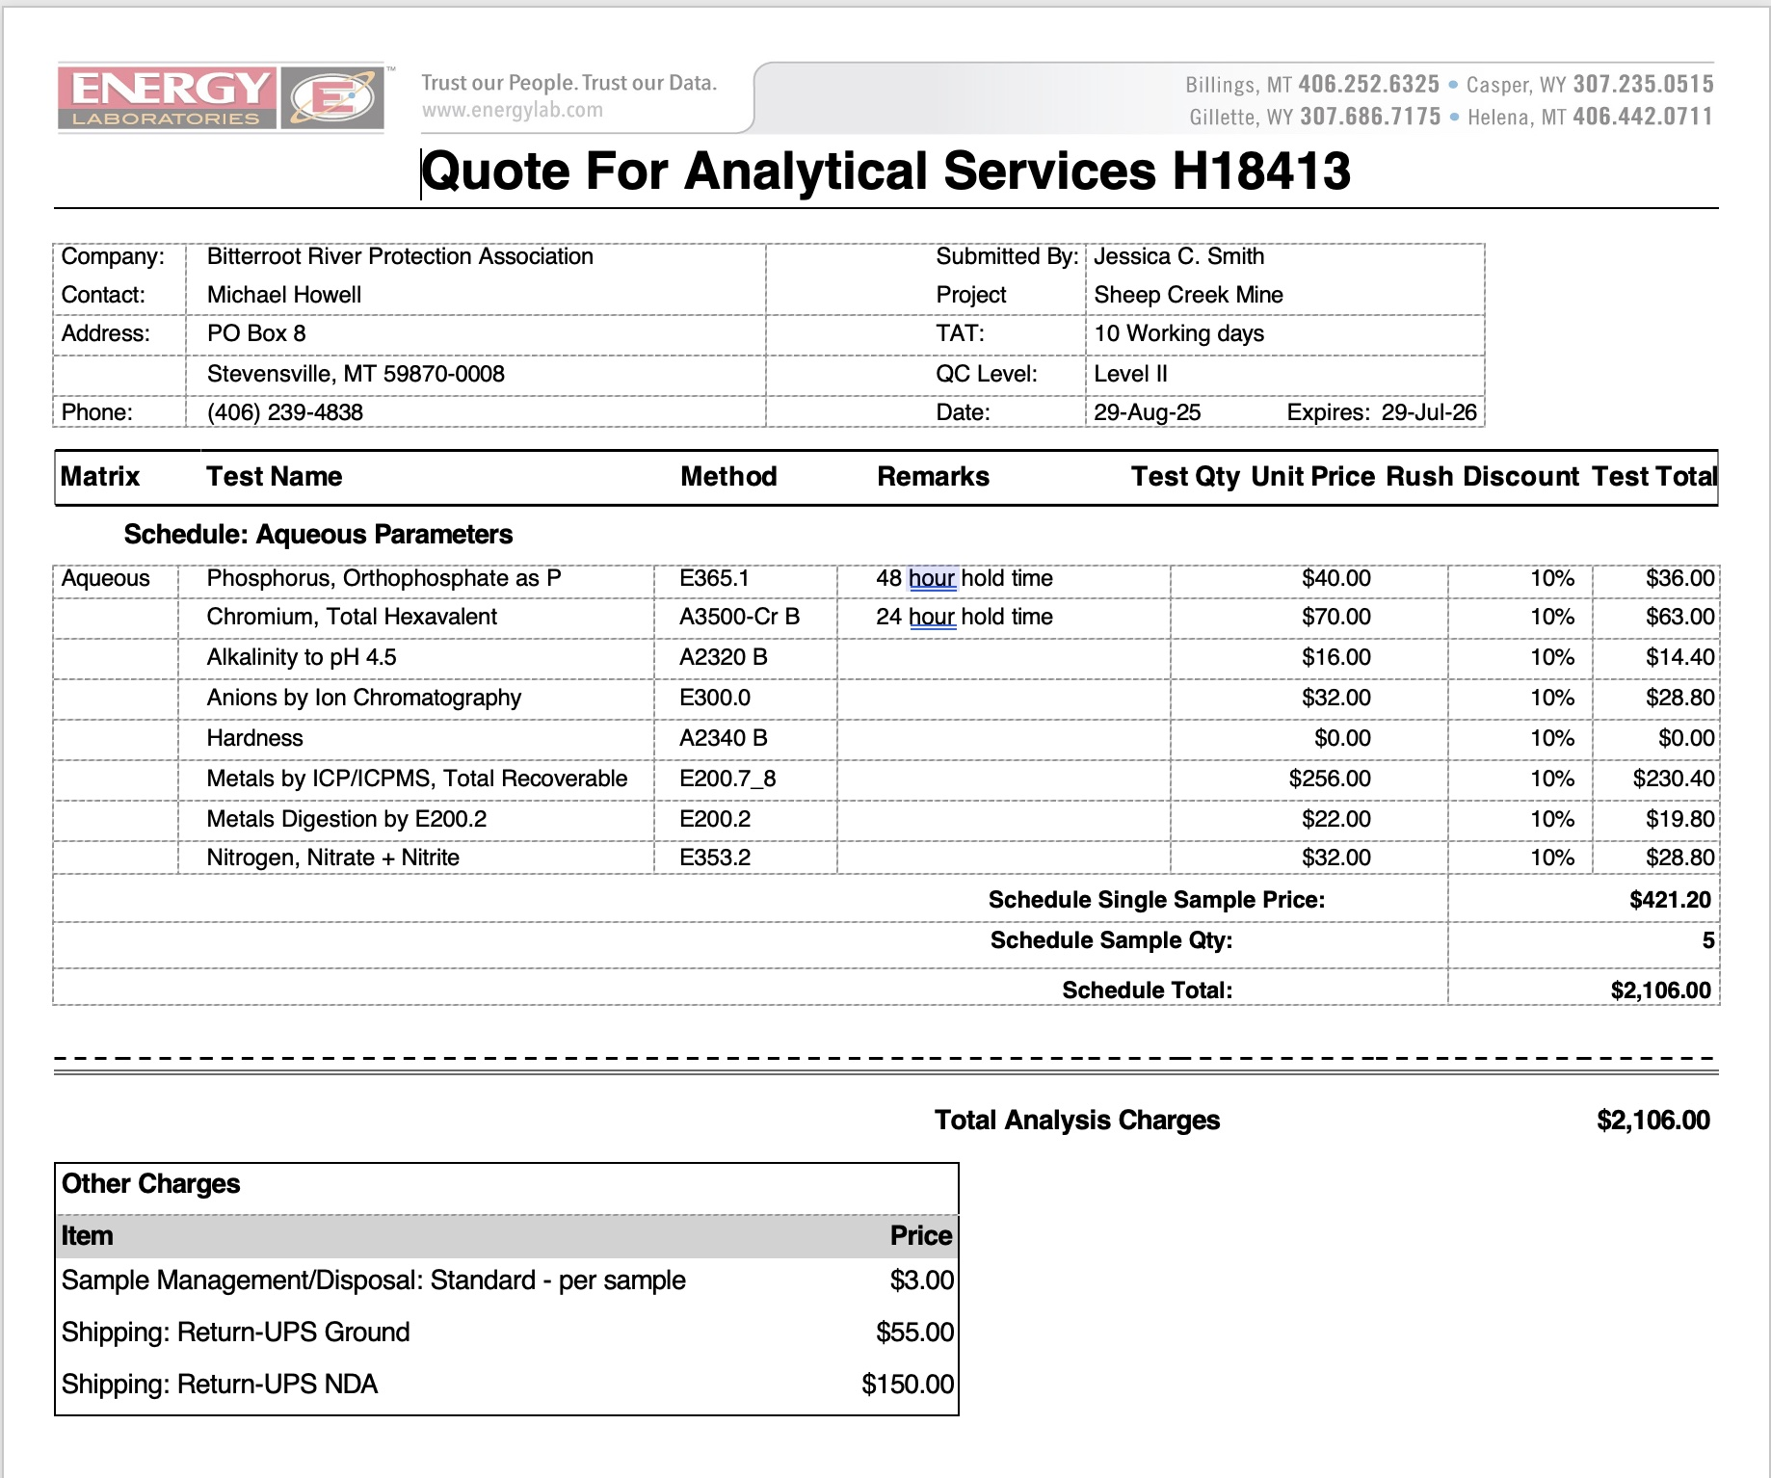

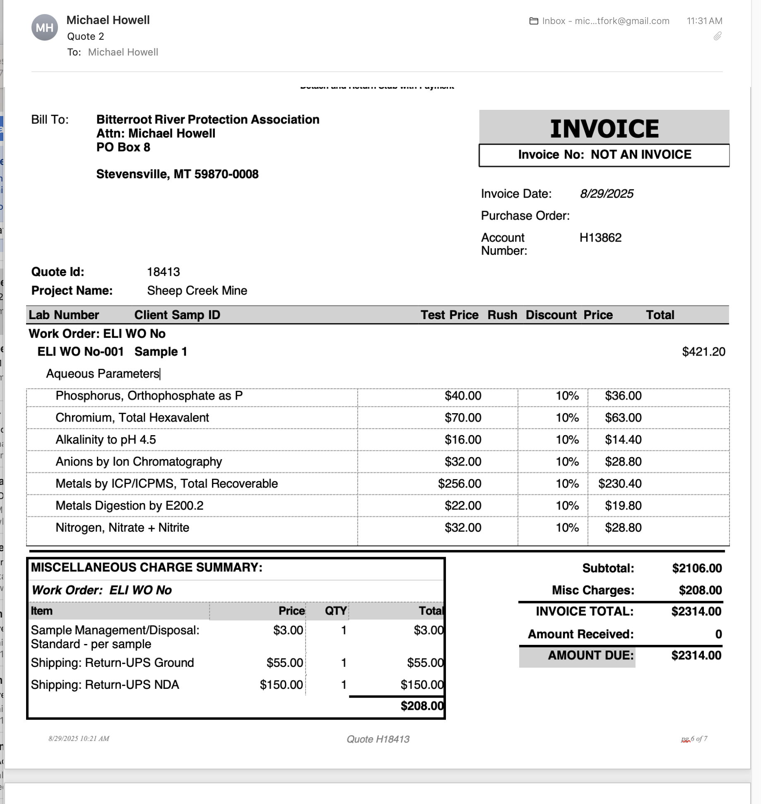
The subtotal is for 3 sample sites PLUS a Duplicate and a Blank for Quality Assurance purposes

Appendix B – Field Forms
BITTERROOT RIVER HEALTH CHECK SITE VISIT FORM
(Refer to notes taped to clipboard for Site ID names and notes for sampling including photographs)

SITE ID: _________________________ DATE: ________________ arrival time: ____________

SAMPLERS-
Name(s) PRINTED: ______________________________________________________________

Signatures _____________________________________________________________________

Others________________________________________________________________________
YSI Pro DSS parameters

(Air temperature) °C | Spec. Conductance µS/cm
Water temperature °C | Total dissolved solids (TDS). mg/L
Barometric Pressure mmHg | pH (standard)
Dissolved Oxygen DO mg/l | Turbidity  NTU
The bottle label should include the initials of the sampler as well as the Site ID and date

ENERGY LAB’s CHECK LIST (The small, filtered bottle should be frozen and the larger bottles refrigerated)
Sample duplicate blank
- 250 ml bottle – White cap (chromium, Total Hexavalent)
Syringe rinsed 3 times in ambient river water and then filled? ______ ______ ______
Bottle rinsed three times in ambient river water and then filled? ______ ______ ______
Firmly capped and placed in cooler? ______ ______ ______
- 500 ml bottle – White cap (Alkalinity, Anions by Ion Chromo)
Syringe rinsed 3 times in ambient river water and then filled? ______ ______ ______
Bottle rinsed three times in ambient river water and then filled? ______ ______ ______
Firmly capped and placed in cooler? ______ ______ ______
- 120 ml bottle – White cap – FILTERED (Orthophosphate as P)
Syringe rinsed 3 times in ambient river water and then filled? ______ ______ ______
Bottle rinsed 3 times with FILTERED water and filled with
FILTERED water (leaving room for expansion)? ______ ______ ______
Firmly capped and placed in cooler? ______ ______ ______
48 hour Holding Time
- 250 ml bottle – Red cap (Metals total recov., hardness, metals digest.)
Syringe rinsed 3 times in ambient river water and then filled? ______ ______ ______
Bottle rinsed three times in ambient river water and then filled? ______ ______ ______
Preservative (HNO3) added? ______ ______ ______
Firmly capped and placed in cooler? ______ ______ ______

- 5. 250 ml bottle – Yellow cap (Nitrogen, Nitrate + Nitrite)
Syringe rinsed 3 times in ambient river water and then filled? ______ ______ ______
Bottle rinsed three times in ambient river water and then filled? ______ ______ ______
Preservative (H2SO4) added? ______ ______ ______
Firmly capped and placed in cooler? ______ ______ ______

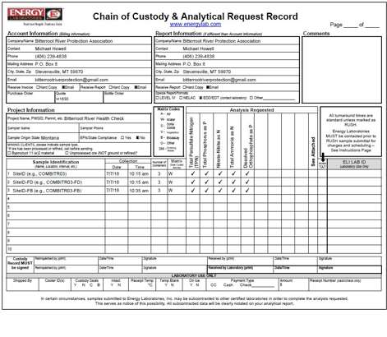
e Environment Dema

YSI CALIBRATION WORKSHEET

Calibration Date Technician: Handheld Serial Number: Handheld Software Version: Cable Serial Number:

Temperature
Reading when sensor is dry and in room temp air: Accurate? Y N

Conductivity
Reading when sensor is dry and in room temp air: Acceptable value is less than 1 µS/cm

Actual Reading in solution before calibration is accepted: Reading in calibration solution after calibration is completed:
Conductivity Cell Constant in GLP* record after calibration:
Acceptable range for ProDSS conductivity/temperature sensors (626902) is 4.5 to 6.5
Acceptable range for integral (i.e. built-in) sensors on ODO/CT assemblies is 4.4 to 6.4

Optical Dissolved Oxygen
Barometric pressure:

Actual Reading before DO% calibration is accepted:
Reading in DO% calibration environment after calibration is completed:

ODO gain in GLP record after calibration: Acceptable range is 0.75 to 1.50

pH
 |  | Actual Readings during calibration
Buffer | Calibration Value | pH | pH mV** | Acceptable pH mV in buffer
7 |  |  |  | -50 mV to 50 mV
4 |  |  |  | +165 to +180 from pH 7 buffer mV value
10 |  |  |  | -165 to -180 from pH 7 buffer mV value
pH slope in GLP record after calibration: Acceptable range is ~ 55 to 60 pH/mV
(Ideal is 59.16 mV/pH)
*GLP stands for Good Laboratory Practice file. This calibration record contains important information about the calibration result.
**The pH mV at the time of calibration (Sensor Value) can also be seen in the final pH GLP record
ORP
Actual Reading in solution before calibration is accepted: Reading in calibration solution after calibration is completed:
ORP Cal Offset in GLP record after calibration: Acceptable range is -100 to 50

Turbidity

Depth (Completed in Air)

Acceptable range for Actual Reading during calibration of the first point is -10 to 10 FNU
Calibration value (FNU)* | Actual Reading during calibration
0
12.4*
124*
1010

*Note: The turbidity sensor can be calibrated to 3 points. Either 12.4 or 124 FNU standard can be used for the second point, but not both. Other calibration values can be used when calibrating.

Actual Reading before calibration is accepted: Reading in air after calibration is completed:
Ammonium

 | Actual Readings during calibration
Concentration** (i.e. Calibration Value) | mg/L | mV*** | Acceptable mV when the sensor is new
1st point: 1 mg/L |  |  | -20 mV to 20 mV
2nd point: 100 mg/L |  |  | +90 to +130 from mV value in 1 mg/L standard
Nitrate

 | Actual Readings during calibration
Concentration** (i.e. Calibration Value) | mg/L | mV*** | Acceptable mV when the sensor is new
1st point: 1 mg/L |  |  | 180 mV to 220 mV
2nd point: 100 mg/L |  |  | -90 to -130 from mV value in 1 mg/L standard
Chloride

 | Actual Readings during calibration
Concentration** (i.e. Calibration Value) | mg/L | mV*** | Acceptable mV when the sensor is new
1st point: 10 mg/L |  |  | 205 mV to 245 mV
2nd point: 1,000 mg/L |  |  | -80 to -130 from mV value in 10 mg/L standard
**Other standard concentrations can be used. A 2 point calibration without chilling a third calibration solution is extremely accurate and is the preferred method. However, if there is a large temperature variation during sampling, a chilled third calibration point is recommended.
***The mV at the time of calibration (Sensor Value) for each point can also be seen in the GLP record after a calibration is complete.

Tel +1 937.767.7241
800.897.4151 (US)
info@ysi.com YSI.com

©2017 YSI, a xylem brand
Printed in the USA. W87 0117

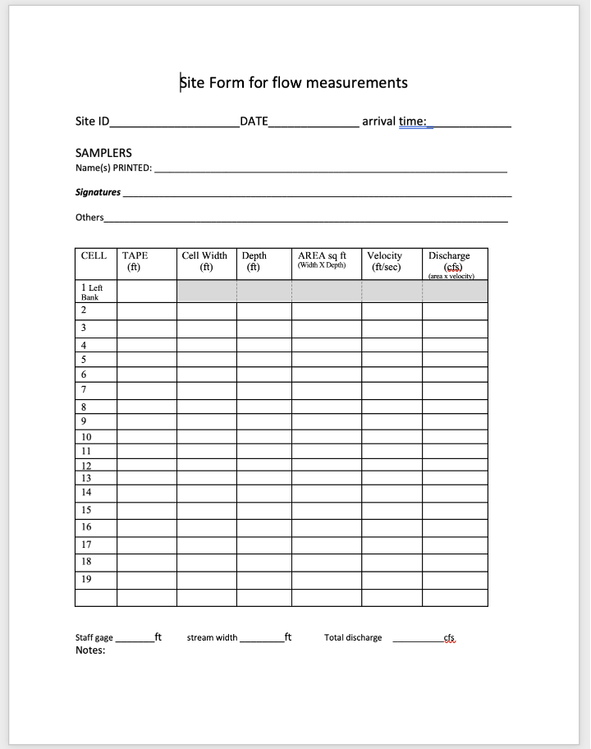

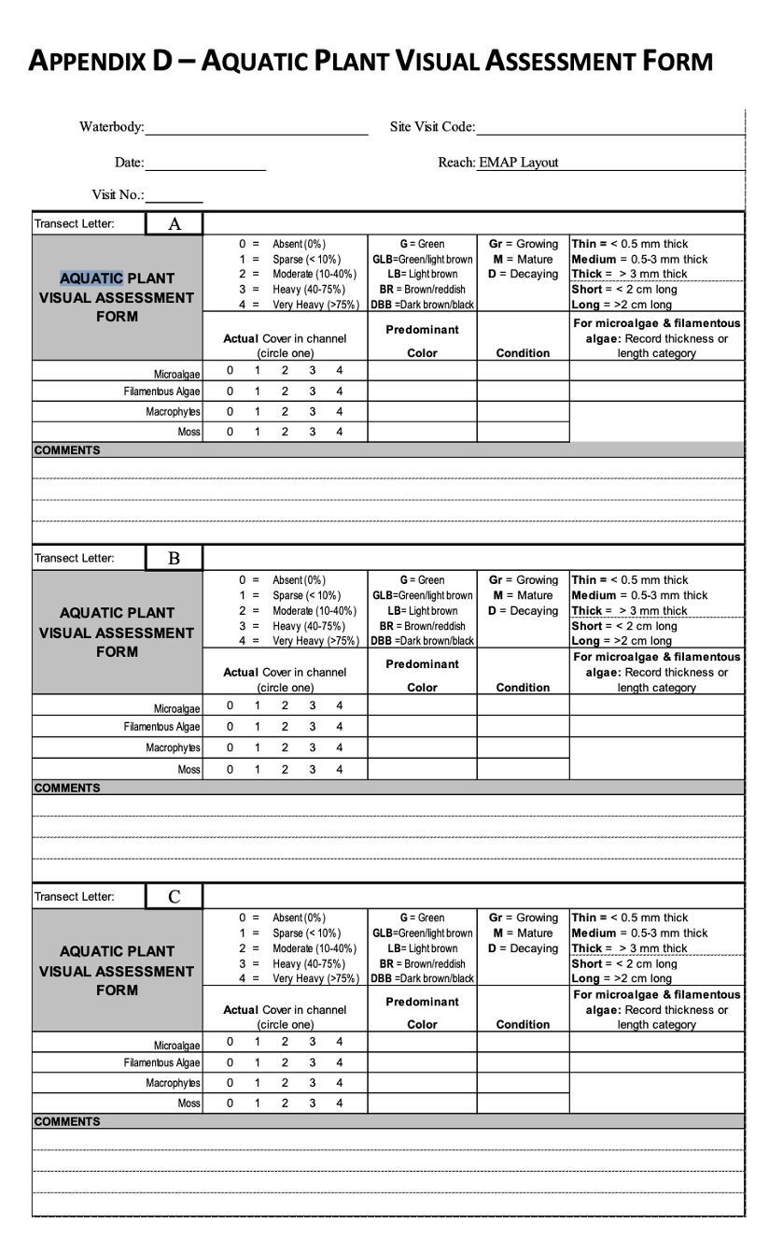

Appendix c – Equipment and supplies

Equipment and supplies list for sampling

DOCUMENTS:
Field Manual
SAP for project
Laminated sheets with instructions for:
- taking nutrient and metal water samples
- taking metal sediment samples
- collecting ysi data
- collecting flow measurements
Rain proof Site Visit Forms for recording Nutrient & metal samples ; YSI and Flow data collection
Log book containing YSI calibration records

GEAR & PARAPHENALIA
Sharpies
Pencils
Water proof clip boards
Cooler
sampling bottles (including blanks and duplicates)
filters/syringes (including spares)
ice
DI Water for blanks
latex gloves
wading boots
First Aid kit
Colored ribbons
Tape
Water bottles for drinking and cleaning
Chemicals for cleaning tools

EQUIPMENT

YSI ProDSS, case w/spare parts and tools
GLOBAL FLOW METER
100ft measuring tape
Stakes to secure measuring tape on stream bank
pliers/screw drivers/hammer/wrenches
air thermometer
I-phone
GPS- Garmain

Appendix D – QA/QC Terms and Definitions
Accuracy. A data quality indicator, accuracy is the extent of agreement between an observed value (sampling result) and the accepted, or true, value of the parameter being measured. High accuracy can be defined as a combination of high precision and low bias.

Analyte. Within a medium, such as water, an analyte is a property or substance to be measured. Examples of analytes would include pH, dissolved oxygen, bacteria, and heavy metals.

Bias. Often used as a data quality indicator, bias is the degree of systematic error present in the assessment or analysis process. When bias is present, the sampling result value will differ from the accepted, or true, value of the parameter being assessed.

Blind sample. A type of sample used for quality control purposes, a blind sample is a sample submitted to an analyst without their knowledge of its identity or composition. Blind samples are used to test the analyst’s or laboratory’s expertise in performing the sample analysis.

Comparability. A data quality indicator, comparability is the degree to which different methods, data sets, and/or decisions agree or are similar.

Completeness. A data quality indicator that is generally expressed as a percentage, completeness is the amount of valid data obtained compared to the amount of data planned.

Data users. The group(s) that will be applying the data results for some purpose. Data users can include the monitors themselves as well as government agencies, schools, universities, businesses, watershed organizations, and community groups.

Data quality indicators (DQIs). DQIs are attributes of samples that allow for assessment of data quality. These include precision, accuracy, bias, sensitivity, comparability, representativeness and completeness.

Data quality objectives (DQOs). Data quality objectives are quantitative and qualitative statements describing the degree of the data’s acceptability or utility to the data user(s). They include data quality indicators (DQIs) such as accuracy, precision, representativeness, comparability, and completeness. DQOs specify the quality of the data needed in order to meet the monitoring project's goals. The planning process for ensuring environmental data are of the type, quality, and quantity needed for decision making is called the DQO process. Madison Stream Team Sampling and Analysis Plan Page 23

Detection limit. Applied to both methods and equipment, detection limits are the lowest concentration of a target analyte that a given method or piece of equipment can reliably ascertain and report as greater than zero.

Duplicate sample. Used for quality control purposes, duplicate samples are an additional sample taken at the same time from, and representative of, the same site that are carried through all assessment and analytical procedures in an identical manner. Duplicate samples are used to measure natural variability as well as the precision of a method, monitor, and/or analyst. More than two duplicate samples are referred to as replicate samples.

Environmental sample. An environmental sample is a specimen of any material collected from an environmental source, such as water or macroinvertebrates collected from a stream, lake, or estuary.

Field blank. Used for quality control purposes, a field blank is a “clean” sample (e.g., distilled water) that is otherwise treated the same as other samples taken from the field. Field blanks are submitted to the analyst along with all other samples and are used to detect any contaminants that may be introduced during sample collection, storage, analysis, and transport.

Instrument detection limit. The instrument detection limit is the lowest concentration of a given substance or analyte that can be reliably detected by analytical equipment or instruments (see detection limit).

Matrix. A matrix is a specific type of medium, such as surface water or sediment, in which the analyte of interest may be contained.

Measurement Range. The measurement range is the extent of reliable readings of an instrument or measuring device, as specified by the manufacturer.

Method detection limit (MDL). The MDL is the lowest concentration of a given substance or analyte that can be reliably detected by an analytical procedure (see detection limit).

Precision. A data quality indicator, precision measures the level of agreement or variability among a set of repeated measurements, obtained under similar conditions. Relative percent difference (RPD) is an example of a way to calculate precision by looking at the difference between results for two duplicate samples.

Protocols. Protocols are detailed, written, standardized procedures for field and/or laboratory operations.

Quality assurance (QA). QA is the process of ensuring quality in data collection including: developing a plan, using established procedures, documenting field activities, implementing planned activities, assessing and improving the data collection process and assessing data quality by evaluating field and lab quality control (QC) samples.

Quality assurance project plan (QAPP). A QAPP is a formal written document describing the detailed quality control procedures that will be used to achieve a specific project’s data quality requirements. This is an overarching document that might cover a number of smaller projects a group is working on. A QAPP may have a number of sample analysis plans (SAPs) that operate underneath it.

Quality control (QC). QC samples are the blank, duplicate and spike samples that are collected in the field and/or created in the lab for analysis to ensure the integrity of samples and the quality of the data produced by the lab.

Relative percent difference (RPD). RPD is an alternative to standard deviation, expressed as a percentage and used to determine precision when only two measurement values are available. Calculated with the following formula: RPD as % = ((D1 – D2)/((D1 + D2)/2)) x 100 Where: D1 is first replicate result D2 is second replicate result

Replicate samples. See duplicate samples.

Representativeness. A data quality indicator, representativeness is the degree to which data accurately and precisely portray the actual or true environmental condition measured.

Sampling and Analysis Plan (SAP). A SAP is a document outlining objectives, data collection schedule, methods and data quality assurance measures for a project.

Sensitivity. Related to detection limits, sensitivity refers to the capability of a method or instrument to discriminate between measurement responses representing different levels of a variable of interest. The more sensitive a method is, the better able it is to detect lower concentrations of a variable.

Spiked samples. Used for quality control purposes, a spiked sample is a sample to which a known concentration of the target analyte has been added. When analyzed, the difference between an environmental sample and the analyte’s concentration in a spiked sample should be equivalent to the amount added to the spiked sample.

Standard operating procedures (SOPs). An SOP is a written document detailing the prescribed and established methods used for performing project operations, analyses, or actions.

